 | Weekly Insights | Oct 23, 2025
 | Item | Page
 | Stories of the Week | 1
 | Corn | 30
 | Wheat | 32
 | Soybeans | 34
 | Soybean Meal | 36
 | Soybean Oil | 38
 | Weekly Prices | 40

Executive Summary
Corn – Futures Stable, Dec/Mar Carry Narrows on Export Pull
December corn settled at $4.36/bu, up 2¢ from $4.34 last week, as basis strength and solid inspections balanced remaining harvest pressure. The Dec/Mar spread narrowed slightly to 14.5¢ (64 percent of full carry), reflecting firm nearby demand from Gulf exporters and ethanol producers. CIF Gulf bids rose another two cents amid limited barge availability, and inspections for the week ended Nov 7 reached 1.42 MMT (–17 percent w/w), still 76 percent above last year level The average analysts WASDE preview points to unchanged US production but minor upward revisions to export demand (+75 mbu median estimate), lifting the 2025/26 export projection to 2.300 billion bushels.

Wheat – Board Gains Continue, Russian Offers Steady but Tightening
December SRW wheat settled at $5.34/bu, down 19¢ from $5.53 last week but still holding a portion of the recent three-week rebound as Plains dryness persisted and speculative shorts likely trimmed exposure. The Dec/Mar spread narrowed to 14.5¢ (58 percent of carry), while FOB Russia offers moved up $2/MT and US HRW premiums held firm. Weekly inspections were 290k mt (down 17 percent week on week), with Indonesia and Mexico the top destinations. Analysts WASDE consensus sees little change to US supply and demand expectations but a modest bump in Russian export estimates and tighter Argentine production outlook.
Soybeans – Futures Edge Higher on Verbal Framework Chatter, Gulf Basis Diverges
January soybeans rose eight cents to $11.32/bu (about +0.7 percent), supported by market chatter about a US–China verbal purchase framework, though soybeans were not included in China’s tariff rollback and no confirmed Chinese purchases of US oilseeds have been reported. CIF bids were flat to two cents softer w/w as barge freight in the Lower Mississippi River rebounded, while processor bids in the East remained steady to firm. The Jan/Mar spread widened to 14¢ (61 percent of full carry), consistent with steady crush margins despite subdued export pull. Export inspections dipped to 1.09 MMT, up from 0.984 last week. Expectations ahead of USDA’s November WASDE predict the agency will hold its 2025/26 production and crush projections unchanged. In contrast there are a wide range of views on Chinese imports (98–105 MMT), but it is notable that USDA’s optimistic 112 MMT prediction in September, while an increase of 5.5 million tonnes over the 106.5 MMT imported in 2024/25, was in line with the 2023/24 total volume. That said, If USDA matches analysts’ expectations in Friday’s report, it would imply a seven to 14 MMT DECREASE in Chinese soybean import demand from USDA’s September update.

(Carry % calculated assuming 7% annual interest and \$0.05/bu per month storage/insurance cost over the spread interval.)

Macro/Policy – Crude Weakens, Dollar Flat, China Tariff Cuts Drive Sentiment
Crude oil eased to around $59/bbl (down roughly four percent w/w), weighing on biofuel margins but offering freight relief. The US Dollar Index held at 99.6, while the BRL slipped slightly to 5.27 and the peso continued to weaken in the parallel market (ARS 1,410 per USD), maintaining export-seller pressure amid macro uncertainty. Markets absorbed China’s Nov 10 tariff suspension on US corn and wheat (soybeans remain under a 10–13 percent duty) and unconfirmed reports of a verbal framework for 12 MMT of late-2025 US soybean purchases, which cannot yet be verified in USDA data given the ongoing shutdown and lack of daily sales reports.
Weather – US Harvest Wraps, Central Brazil Sees Patchy Relief

Harvest was effectively complete as of Nov 10, with corn near 92 percent and soybeans near 96 percent finished. Southern barge routes reopened with improved flow in the Lower Mississippi, but persistent dryness remains in central Mato Grosso and Goiás. Rains early in the week improved seeding pace, but deeper soil moisture deficits linger. In Argentina, cooler, dry weather aided corn planting and preserved subsoil reserves, while wheat entered fill under mostly favorable conditions.
What’s Next (Nov 13 – Nov 19):
WASDE (Nov 14): Watch for any yield revisions or China import shifts. Averages of analyst estimates show steady corn/soy production but a potential 75-million-bushel increase in predicted 2025/26 US corn exports and a modest decrease in USDA’s prediction of 2025/26 US soybean ending stocks.
River Freight Trends: Monitor Cairo–Memphis freight index after recent barge draft improvements; further relief could lift CIF basis.
Brazil Rainfall Outlook: Any confirmation of a dry bias through Nov 20 could accelerate speculative soy and meal buying.
Export Sales Catch-Up: USDA’s backlog of sales data may reveal stronger soy activity in early November, key for detecting any shift in China’s forward purchase behavior.
Ethanol Margins: With crude slipping, next EIA data (Nov 13) will indicate if weekly run rates remain close to 1.123 mbpd.
China Buying Pace: Given the unconfirmed verbal framework, any actual purchase volume or shipment timing (Q4 vs Q1) will be crucial for basis and board strength.
Table A – CME Futures (Front Contracts)
(Prices in USD per bushel, volume/open interest in contracts)
Contract (Front Month) | 11/05/2025 Close | 11/12/2025 Close | Change (Δ) | Δ% | 5-day Realized Vol* (x) | Open Interest Δ  (x)
Corn (Dec ’25) | $4.34 | $4.36 | +$0.02 | +0.46% | 13% (ann.) | -28k (est.)
Soybeans (Jan ’25) | $11.24 | $11.32 | +$0.08 | +0.71% | 12% (ann.) | +7k (est.)
Wheat (Dec ’25) | $5.53 | $5.34 | -$0.19 | -3.44% | 20% (ann.) | -4k (est.)
5-day realized volatility estimated from daily settlement price changes.
Actual contract open interest changes are estimated; total corn OI rose slightly as new-crop hedges built, while wheat OI fell with Sep contract deliveries.
Table B – Key Calendar Spreads & % of Full Carry
Spread (Crop ‘25→‘26) | 11/05  Quote | 11/12  Quote | Δ (carry) | % Full Carry* | Market Implication
Corn Dec–Mar | -$0.14 | -$0.14 | +0.00 | 64% | Nearby Gulf demand firming vs. interior harvest flow
Soy Jan–Mar | -$0.11 | -$0.14 | -0.03 | 61% | Crush pull holding January, export sales still Brazil-facing
Wheat Dec–Mar | -$0.13 | -$0.14 | -0.01 | 58% | Plains dryness supporting spreads, but Black Sea competition wide
Assumes 7% annual interest + $0.05/bu/month storage/insurance. Full carry (3 months) ≈ $0.22–$0.23 for corn & SRW wheat; (2 months) ≈ $0.22 for soybeans. % of full carry = (calendar spread ÷ calculated full carry).
Table C – Notable International Futures (weekly moves, if significant):
Exchange (Front Month) | 11/05 USD Price | 11/12 USD Price | Δ% | Notes
Dalian Corn (Jan) | ¥2,141($6.40/bu) | ¥2,151($6.46/bu) | +0.5% | China corn futures held firm on steady feed demand; domestic prices remain well above import parity even after tariff rollback.
Dalian Soymeal (Jan) |  |  | -1.7% | Soymeal eased on sluggish hog margins, with steady inclusion rates but subdued feed demand.
  ¥3,100
  ($436/mt)
  ¥3,046
  ($429/mt)
B3 (São Paulo) Corn (Nov) |  |  | -0.7% | Brazilian corn softened slightly on steady domestic logistics and competitive US Gulf offers into MENA and Asia.
  R$64.68
  ($11.85)
  R$64.20
  ($11.75)
Euronext Wheat (Dec) |  |  | +0.8% | EU wheat held steady amid ample stocks; slight firmness capped by cheap Black Sea offers.
  €194 ($221.46 mt)
  €196 ($223/mt)

Corn Market Deep Dive
Pre-WASDE Positioning: The trade enters Friday’s WASDE expecting minimal change to estimated US corn supply but modest strength on the demand side. According polling between November 10–12, the average analyst forecast holds yield at 183.5 bu/acre and production at 15.557 billion bushels. Ending stocks are seen near 2.100 billion bushels, with the key expected change being a +75 mbu increase in exports to 2.300 billion, justified by strong inspections and firm Gulf basis. Ethanol use is projected flat at 5.4 billion bushels, with no consensus for feed or residual adjustments. On the global side, trade looks for a Russian crop of 59 MMT, Argentina around 52 MMT, Brazil at 132.8 MMT, and Chinese imports near 7 MMT. If realized, the report would validate stronger front-end demand and justify Dec/Mar firmness, though futures may need actual Chinese demand or South American weather stress to extend higher. Market tone remains balanced, not bearish, but requires a fresh bullish trigger.
Futures & Spreads: December corn settled at $4.36/bu, up two cents from $4.34 last week, as basis strength and solid Gulf pull offset harvest-weighted flows. The Dec/Mar spread narrowed to 14.5¢ (64 percent of full carry), the tightest since September, signaling stronger nearby demand. Five-day realized volatility held near 13 percent annualized with flat skew, leaving the price tone steady but underpinned.
Funds & Positioning: No official CFTC data have been published due to the federal shutdown. Private estimates indicate managed money net short roughly –94 k contracts, a 15k reduction from the prior period, consistent with light short-covering ahead of the WASDE.
US Cash & Basis: CIF basis climbed to +94¢ over Dec, up 2¢ w/w, with active loadings to Mexico and Central America. Illinois River basis improved to –20¢ under, while the Lower Mississippi firmed to –42¢ to –45¢ under as river levels at Memphis continued to improve toward –7 ft, reducing draft restrictions and easing barge congestion. Ethanol plants across the western Corn Belt held firm at +15¢ to +20¢ over, supported by solid margins and weekly run rates near 1.123 mbpd. The national average basis stood around –38¢ under, essentially unchanged on the week.
Export Flows: FGIS reported inspections of 1.42 MMT for the week ending Nov 7, down 17 percent w/w from 1.669 MMT, yet still 76 percent above the same week last year. Gulf loadings led, with Mexico, Colombia, and South Korea the top destinations. US FOB Gulf offers were about $210/MT ($5.27/bu), roughly $10/MT above Brazilian offers into Asia. No flash sales were confirmed, though private chatter pointed to new bookings near 1.0 MMT.
International Trade: Brazil FOB Santos corn stood around $210/MT ($5.30/bu), maintaining a freight-adjusted edge into Asia. November exports are pacing near 6.04 MMT, slightly below October but still seasonally strong. Mato Grosso interior prices hovered near R$ 57/sc, equivalent to roughly $180/MT or $4.59/bu, keeping domestic Brazil corn well below US Gulf values. Argentina’s Up-River FOB was $205/MT ($5.17/bu) amid firm EU/MENA demand. Rosario corn planting was 40 percent complete as of Nov 9. Dalian January corn futures traded near ¥2,200/MT ($6.62/bu), keeping Chinese domestic prices well above import parity. Although US corn regained tariff-free access, no new Chinese bookings had been confirmed by Nov 12.
So What? The corn market shows subtle strength beneath the surface: spreads firmed, CIF basis improved, and Gulf flows stayed active even as futures held flat. Managed money trimmed shorts, ethanol demand remained steady around 1.123 mbpd, and export inspections, while lower w/w, still outperformed last year. If the WASDE confirms the expected export lift and Brazil’s weather stays erratic, December futures could test $4.38–$4.43. Until then, spreads and basis remain the clearest indicators of front-end firmness.

Soybean Market Deep Dive
Pre-WASDE Positioning: The trade expects few changes to the US soybean balance sheet in the Nov 14 WASDE. The average yield estimate of 53.0 bu/acre (unchanged from October), leaves production unchanged at 4.300 billion bushels. Analysts see 2025/26 ending stocks at 304 million bushels, with no change to crush (2.400 billion) or exports (1.800 billion) in most forecasts. The range of estimates is narrow and reflects little pressure for adjustment without new China sales or a major yield revision. Globally, the Brazilian crop is expected to stay near 165 MMT despite early-season dryness, while the 50 MMT outlook for Argentine production may come under scrutiny in future reports. The average of analysts’ 2025/26 Chinese import forecasts suggest USDA will cut its predicted volume to near 100 MMT, down 12 MMT from September. The market bias is neutral to slightly supportive, with few catalysts unless USDA surprises on exports or traders front-run dryness in Mato Grosso.
Futures & Spreads: January 2026 soybeans closed at $11.32/bu, gaining 8¢ on the week after posting a one-year high the prior Friday. The Jan/Mar spread widened to 14¢ carry, equal to 61 percent of full commercial carry (six percent interest, $0.05/bu/month), reflecting a well-supplied front end with active crushers but soft export pull. Trade volume stayed steady, and volatility remained contained, suggesting commercial buying rather than fund re-entry.
Products & Crush: Board crush margins remained positive with margins still supported by strong meal basis and seasonal oil yield improvements. Soybean oil traded near 50.6¢/lb, tracking weaker crude oil, while soymeal prices hovered around $322/short ton. Gross crush margins stayed above seasonal averages. NOPA’s official October report was not released within the window, but private estimates pegged crush above 200 mbu, up roughly 5 percent from last year.
Funds & Positioning: CFTC data remain unavailable due to the shutdown, but private positioning estimates show managed money net long around 30k contracts, up roughly 8k w/w, as traders added light longs on China tariff optimism and Brazilian weather risk. CME open interest increased modestly, with most growth concentrated in the Jan/Mar spread. The curve remains well-behaved, with no inversion or nearby tightness.
Cash & Basis: Processor bids across the Eastern Corn Belt held firm, generally referenced against the December contract, supported by strong crush margins and steady soymeal demand. Gulf CIF basis softened slightly as barge traffic improved but export pull from China remained weak, with offers drifting a few cents lower on the week. Interior river bids improved marginally where freight conditions normalized, particularly along the Ohio and Lower Mississippi. National soybean basis was broadly steady, averaging around –76¢ under the January futures equivalent, showing little net change on the week.
Trade Flows & International Competition: USDA reported soybean inspections at 1.09 MMT for the week ending Nov 7, the lowest in five weeks and about 42 percent below the same week last year. Brazil shipped over 7.3 MMT in October and remained the primary supplier to China. FOB Santos was near $480/MT ($10.92/bu equivalent), undercutting the US Gulf by about $8/MT. Chinese crushers booked December and March Brazilian arrivals, while US flash sales remained absent. Argentine soy flows were limited, with local crushers capturing most domestic supply.
Policy Context: China’s Nov 10 tariff rollback did not include soybeans, which remain subject to the 13 percent MFN duty. Trade sources cited an unconfirmed verbal framework discussed by officials for up to 12 MMT in late-2025 purchases and annual targets near 25 MMT through 2028, but no formal confirmation or USDA daily sales followed. Traders remain cautious, treating the framework as intent rather than execution.
So What? The board is supported by crush, not exports. Basis is stable, spreads show no front-end squeeze, and the Jan/Mar carry widened modestly. Without confirmed Chinese purchases or fresh weather deterioration in Brazil, the complex likely stays rangebound in the $11.13–$11.33 zone. Until then, structure continues to favor crushers and steady ownership rather than rallies.

Wheat Market Deep Dive
Pre-WASDE Positioning: Traders expect little change to USDA’s expectations for the US wheat balance sheets in the Nov 14 WASDE. Analysts predict 2025/26 US wheat ending stocks near 862 million bushels (USDA Sep: 844mbu), with no adjustments expected to production or major demand lines. HRW dryness remains a background risk but is unlikely to prompt supply-side revisions this cycle. Globally, pre-WASDE polls point to slightly higher Russian and Argentine wheat crops versus USDA September, though most expect USDA to move gradually rather than fully match private estimates. No changes are anticipated for the EU or Australia. Analysts forecast USDA will project 2025/26 world wheat ending stocks near 266 MMT (Sep: 269 MMT), indicating a broadly flat tone. Trade attention remains focused on Black Sea logistics and Southern Hemisphere weather rather than potential minor US balance-sheet tweaks.

Futures & Spreads: December SRW futures fell 19¢ on the week to $5.34/bu, pulling back after a three-week recovery driven by fund short covering and ongoing Plains dryness. The Dec/Mar spread narrowed to 14.5¢ carry (58 percent of full commercial carry), the tightest since early October, signaling that despite the futures setback, the curve remains supported by storage economics. KC HRW December eased three cents to $5.19/bu, while Minneapolis HRS slipped 2.2¢ to $5.69/bu. Volatility stayed near 20 percent and open interest was steady, reinforcing that the move was largely technical rather than fundamentally driven.
Global Supply & Demand: Russian 12.5 percent FOB offers firmed $3/MT to 232/MT, reflecting seasonal tax adjustments and steady ruble support. Russia remained dominant in GASC and Turkish tenders, undercutting US and French offers. French FOB (Rouen) held near $225/MT, with EU export pace steady. Argentina’s crop was still seen near 16 MMT, though field surveys suggest possible reductions ahead. In Australia, late rain improved East Coast harvest quality, but WA yields are confirmed lower. US HRW planting reached 95 percent as of Nov 10, with emergence at 76 percent; 52 percent rated good to excellent. Dryness lingered in western Kansas and Oklahoma, supporting HRW premiums and calendar spreads.
Cash & Basis: US FOB SRW Gulf offers held near $225/MT ($6.70/bu), about $15/MT over Black Sea comps. HRW FOB values near $240/MT reflected protein premiums but stayed noncompetitive globally. Domestic mill basis in the southern Plains slipped 1–2¢ w/w, with December coverage mostly complete. Interior bids in Kansas and Nebraska remained weak at –48¢ to –53¢ under, consistent with full-carry hedging and slow demand. The HRW premium to SRW widened modestly on limited high-protein availability.
Trade Flows: FGIS inspections reached 290k tonnes for the week ended Nov 7, down 7.5 percent from the prior week and still well below average. Gulf activity rebounded, led by cargoes to Mexico and the Caribbean. Russian and Ukrainian exports stayed strong via Black Sea and Danube routes, keeping pressure on US competitiveness. No US flash sales were reported, and USDA export sales data was still delayed.
Speculative Positioning: No official CFTC data were released due to the ongoing federal shutdown. Market participants relied on private estimates, which indicated only modest position changes, consistent with the week’s technically driven price action rather than any significant shift in speculative appetite.
So What? US wheat strength remains driven by short covering and dryness headlines, not improved export competitiveness. Spreads continue to reward storage, and cash premiums reflect protein sorting rather than tightening supply. Unless Russia restricts flow or Argentina’s production is revised sharply lower, Chicago futures are likely to remain rangebound. Currency moves such as a weaker dollar would not materially change US export competitiveness given how wide the gap is versus Black Sea offers. The market is firming, but it is not tightening.

US Cash Market & Basis
Corn: River basis improved again this week as water levels in the Lower Mississippi held firm, keeping freight costs below recent highs. Illinois River bids strengthened to –20¢ under December, up two cents w/w, while the Lower Miss firmed to –42¢ to –45¢ under amid normalized drafts and steady traffic. Spot freight from Cairo to Memphis held near $19.53/ton, flat to slightly firmer depending on timing. CIF Gulf basis rose to +94¢ over December, up two cents, supported by active loadings and strong Mexican demand. Processor bids in Iowa and Nebraska remained stable at +15¢ to +20¢ over, tracking firm ethanol margins. National average corn basis was near –38¢ under, roughly unchanged on the week.
Soybeans: Processor bids in the Eastern Corn Belt remained firm, supported by positive crush margins and steady soymeal demand. River basis was generally stable to slightly firmer where barge drafts improved along the Illinois and Lower Mississippi, though overall export pull from China remained weak. CIF Gulf soybean basis was steady to a few cents softer on the week, reflecting better logistics but limited new sales. National average soybean basis hovered near –76¢ under the January futures equivalent, little changed from last week.
Wheat: HRW and SRW FOB values held flat near $240/MT and $225/MT, respectively, but Gulf export basis softened by 1–2¢ on quiet demand. Interior bids in Kansas and Oklahoma stayed soft at –48¢ to –53¢ under, driven by carry incentives rather than consumption. Basis levels in the Southern Plains milling market slipped slightly as December coverage remained in place. Domestic demand from flour buyers was stable but showed little new spot interest, keeping interior values defensive.
So What? Logistics steadied as river levels normalized, allowing CIF basis to recover and barge freight to ease off highs. Gulf exporters benefited from improved flow but still face global price headwinds, while processors remained the anchor of cash demand. Basis strength in corn and soy suggests demand is holding pace with post-harvest pressure. Without confirmation of large export programs, particularly to China, processors will continue to set the tone for nearby cash strength.

International Cash & Trade Flows
Brazil: Brazil remained the dominant global supplier of both corn and soybeans, though early November loadings showed a modest slowdown from October’s peak. ANEC pegged November soybean exports near 4.26 MMT so far, with corn pacing close to 6.04 MMT, both strong, but slightly off prior-month records. FOB Santos soybean offers held near $480/MT ($10.92/bu), maintaining a $8/MT advantage over US Gulf equivalents into China. Corn FOB values stayed firm around $210/MT ($5.30/bu), making Brazil the cheapest origin into Southeast Asia. Interior soybean planting reached 55 percent complete in Mato Grosso as of Nov 10, aided by scattered rainfall, though subsoil moisture deficits remain across parts of Goiás and Tocantins. Export corridors at Paranaguá and Santos operated smoothly, with no reported congestion.
Argentina: Up-River FOB prices were steady to slightly lower: corn was offered around $205/MT, while soymeal traded near $305/MT (47% protein basis), both in line with recent export indications. Farmer sales slowed again after the end of the tax-incentive window and ahead of the Nov 24 election. The Rosario Exchange kept its corn planting estimate at 40 percent complete, above average, and reaffirmed a 52 MMT production outlook assuming neutral-to-wet summer weather. The peso continued to weaken in parallel markets, with the unofficial rate near ARS 1,410/USD, maintaining selling pressure despite macro uncertainty. Wheat harvest began in the north under dry but manageable conditions, with crop expectations still ranging from 22–23 MMT. Crushers continued to operate at a steady pace using stocks accumulated during September’s “soy-dollar” program.
China: Import activity remained Brazil-centric. US Gulf soybean offers near +$2.20/bu over Jan futures remained uncompetitive relative to Brazilian cargoes ($2.10 equivalent), keeping Chinese bookings pointed south. Crushers covered December and early Q1 via Brazilian arrivals, while no confirmed US soybean purchases were registered through Nov 12, and no flash sales were reported due to, at least in part, to the US government funding issue. The Nov 10 suspension of Chinese retaliatory tariffs on US corn and wheat (soybeans unchanged at 13% MFN duty), and Dalian Jan corn futures rose to ¥2,151/MT ($6.46/bu equivalent), still well above landed import parity. Market chatter about long-term Chinese soybean commitments (12 MMT in 2025 and 25+ MMT through 2028) persisted, but without official backing the trade treated these as guidance rather than confirmed demand.
EU / Black Sea: Russian FOB wheat offers for 12.5 percent protein rose to $232/MT, up $2–3/MT w/w, as export taxes reset higher. Despite the bump, Russian exporters continued to win major tenders in Egypt and the Middle East. French wheat near $225/MT (Rouen) remained sidelined after recent Maghreb tenders favored Black Sea sellers. Ukraine maintained steady corn flow through Danube and rail with offers near $207/MT into Spain and Italy. EU internal grain availability improved as corn and feed wheat harvests wrapped, limiting fresh import interest. Russian and Ukrainian soymeal continued to displace US product into southern Europe, helped by lower freight and FX tailwinds.
Other Origins: No material changes reported in Canada or South Africa. Canada’s spring wheat exports flowed at a steady pace, mostly to Mexico and East Asia. Australia’s harvest expanded across Queensland and New South Wales, with early results showing improved protein content but mixed yield recovery after a dry winter. India remained inactive in global grain trade, with no export policy shifts announced.
So What? US exporters remain disadvantaged into Asia and MENA as Brazil and Russia maintain price leadership. China’s reluctance to shift from Brazilian beans, even post-tariff rollback, limits Gulf traction. The political timeline in Argentina introduces uncertainty, but not enough to alter flow. Until FOB spreads compress or tariff dynamics shift, US cash strength will rely on domestic demand and CIF rather than international arbitrage.
Key Fundamentals & Reports (Nov 6 – Nov 12)
Government Data & Reporting: Federal operations remained paused early in the week, delaying USDA and CFTC data releases amid the extended shutdown. The regular Crop Progress update was not published on Nov 10 due to the shutdown, leaving harvest progress to private estimates. WASDE and Crop Production remain on schedule for release Friday, Nov 14, alongside updated CFTC Commitments of Traders through Nov 5. Most private forecasts and trade positions were set in anticipation of that report, limiting new directional inputs.
Crop Progress (estimated as of Nov 2): Industry surveys and state updates suggest US corn harvest near 92 percent complete and soybeans roughly 96 percent, both ahead of five-year averages (81 and 88 percent, respectively). Producers in Illinois, Iowa, and Minnesota are largely finished, with only northern fringes of the Corn Belt still active. Winter wheat planting was effectively complete, with emergence estimated near two-thirds to three-quarters of intended acreage. Dryness persisted in western Kansas and Oklahoma, maintaining slight stress in early HRW stands.
Export Inspections (USDA FGIS – week ending Oct 30, published Nov 3): Corn inspections reached 1.42 MMT (–17 percent w/w), continuing to outpace last year’s pace by nearly 76 percent. Soybean inspections fell to 1.09 MMT, the weakest in five weeks, reflecting limited Chinese pull and ongoing competition from Brazil. Wheat loadings totaled 290k tonnes (–7.4 percent w/w), concentrated at the Gulf and PNW but still below seasonal norms. Aggregate flow confirms solid corn performance, subdued soy export pace, and persistently weak wheat competitiveness.
Export Sales (USDA FAS, not published): Weekly sales remained unpublished through Nov 12, though private trackers cited light new soybean sales to “unknown” destinations, likely China, and steady corn commitments to Mexico and Japan. No USDA daily flash sales were reported. Market participants expect catch-up data releases next week, possibly showing backlogged soybean bookings from late October.
Ethanol Production & Stocks (EIA – week ending Oct 31 / published Nov 5): Ethanol output stayed unchanged at 1.123 mbpd. Stocks rose to 22.7 million barrels (+0.3 million w/w), reflecting steady blending and seasonal drawdown. The implied corn grind was around 100 mbu, consistent with firm ethanol margins and processor demand across the Western Corn Belt.
NOPA Crush: No new data were published within the window. Private estimates continued to point toward another historically strong month, with October crush seen above 200 mbu, supported by firm soymeal demand and high board crush margins. Eastern Corn Belt processors maintained strong bids, confirming steady throughput.
CFTC Commitments of Traders: No CFTC reports were released due to the ongoing federal shutdown, leaving the market without official visibility into managed money positioning. Traders relied on private estimates and CME open interest changes, which pointed to only light adjustments across the complex. Private trackers continued to show corn modestly net short (around –90k contracts) with evidence of minor short-covering, soybeans modestly net long after small additions early in the week, and wheat still heavily net short, though with limited movement in either direction. With no official fund data, market behavior remained driven primarily by physical flow, spreads, basis strength, and pre-WASDE positioning rather than speculative conviction.
So What? Official data flow remains limited, and market direction continues to be driven by physical movement rather than government statistics. Corn fundamentals lean supportive, firm ethanol use, strong CIF, and robust inspections, while soybeans face sluggish exports and reliance on crush margins. Wheat’s bounce remains technical, not structural. With Crop Progress absent and the WASDE imminent, the next decisive input for traders will be Friday’s report and any confirmation of South American weather stress or China buying.

International Reports:
Brazil – ANEC Lineups & Weather Recovery: Early-November ANEC data show Brazil’s soybean exports tracking near 4.26 MMT for the month to date and corn at roughly 6.04 MMT, consistent with strong second-crop movement but below October’s record pace. FOB Santos soybeans held near $480/MT ($10.92/bu), maintaining an $8/MT discount to US Gulf, while corn offers around $210/MT ($5.30/bu) continued to lead global feed grain pricing. Mato Grosso soybean planting advanced to about 55 percent by Nov 10, aided by improved rainfall during the first half of the month, though cumulative soil moisture across central Goiás and Tocantins remains 30 percent below normal. CONAB did not publish a new bulletin within the window, but private sources expect it to trim early-season soybean yield assumptions slightly in its next update. Logistics through BR-163 and ports at Santos and Paranaguá remained fluid, with no reported congestion.
Argentina – BCBA & MAGyP Updates: The Buenos Aires Grain Exchange reported corn planting at 40 percent complete as of Nov 7, ahead of last year’s pace, while soy planting reached roughly 10 percent with good moisture in core areas. Wheat harvest advanced in northern provinces, and BCBA maintained national production expectations near 23 MMT. MAGyP’s weekly report confirmed continued stability in corn and soybean sowing progress. Up-River FOB corn offers were quoted near $205/MT, soymeal around $305/MT, both steady week-on-week. The peso weakened further to roughly 1,410 per USD in parallel markets, sustaining export incentives. Farmer selling slowed ahead of the Nov 24 presidential runoff, with crushers operating on stocks accumulated under September’s “soy dollar 5” program.
China – Post-Tariff Adjustment & Import Behavior: Following the Nov 10 suspension of retaliatory tariffs on US corn, wheat, and sorghum, Chinese buyers maintained a cautious stance. No new confirmed US soybean purchases were registered, and crushers continued sourcing primarily from Brazil for December–March arrivals. US Gulf soybeans remained about $8/MT above Brazilian equivalents on a landed basis. Dalian Jan corn futures settled near ¥2,151/MT ($6.46/bu eq), soybeans around ¥4,970/MT, and soymeal ¥3,046/MT, all largely stable week-to-week. CNGOIC’s early-November feed grain update noted steady consumption but warned that hog-sector profitability remains low, curbing aggressive feed demand. No new import or reserve announcements were made by MARA or Customs during the period.
Black Sea / EU – Russia Maintains Price Control: Russian 12.5 percent wheat FOB offers increased to $232/MT (+2 w/w) as the export tax adjusted higher with ruble stability. Despite firmer values, Russia continued to dominate GASC and Turkish tenders. Ukrainian corn offers through Danube ports held near $207/MT, competitive into southern EU markets. The European Commission’s November 7 crop monitor confirmed good planting progress for 2026 EU winter cereals, with FranceAgriMer rating 68 percent of French wheat good-to-excellent. EU feed grain availability remained comfortable, and Rouen wheat offers stayed near $225/MT. No major disruptions were reported in logistics across the Black Sea or Danube corridor.
Global – Multilateral Updates: No new AMIS or FAO reports were released during the week. The International Grains Council’s latest figures (Oct 31 update) continue to guide sentiment, showing global 2025/26 wheat stocks at 270 MMT, corn at 330 MMT, and soybeans at 410 MMT. Global trade tone remained neutral, with risk concentrated on South American rainfall distribution rather than geopolitical shocks.
So What? Global flows remain anchored by Brazil’s corn and soybean dominance and Russia’s control of wheat exports. Argentina’s planting pace and currency depreciation keep it competitive but add political risk premium ahead of elections. China’s post-tariff adjustment has yet to yield meaningful new US buying, leaving Gulf differentials wide. With no new multilateral revisions and freight routes running smoothly, world grain values continue to price off export competition rather than scarcity. The next catalyst rests with Brazil’s November rainfall and any follow-through from Chinese demand, both will determine whether the mild firmness in US basis evolves into sustained board support.

Weather & Crop Conditions
United States
Crop Progress & Rainfall: Most harvest activity wrapped up across the Midwest under open skies and warm temperatures. Private estimates place corn harvest around 92 percent complete and soybeans near 96 percent, both ahead of normal pace. Light showers early in the week helped replenish surface moisture in parts of the Ohio and Lower Mississippi Valleys, improving barge draft conditions but having little agronomic effect. In the Plains, winter wheat establishment remains mixed, topsoil moisture deficits persist in western Kansas and Oklahoma, where much of the region received 10-20 mm of precipitation over the past two weeks.
River Levels & Logistics: The Mississippi River system continued to stabilize following late-October rains. Gauge readings at Memphis and Baton Rouge rose modestly, allowing standard barge drafts to resume and freight rates to hold near $19.53/ton on the Cairo–Memphis route. Traffic flows normalized, but carriers reported that water levels remain below average, keeping transport margins tight and delivery windows sensitive to rainfall patterns.
Temperatures: Temperatures stayed seasonally mild, with daytime highs in the 60s–70s°F across the Corn Belt and low 80s°F in the southern Plains. The continued warmth aided late harvest and natural dry-down but accelerated topsoil moisture depletion in the HRW belt. No frost damage or crop-quality issues were reported.
Outlook (6–10 days): NOAA’s Nov 11 outlook projected a drier trend across the central and western Corn Belt, with limited rainfall for Kansas and Nebraska. Higher precipitation probabilities were confined to the lower Mississippi basin and eastern Midwest, suggesting localized river improvement but continued dryness across the Plains. Temperatures are expected to remain above normal, further slowing soil recharge in wheat areas.
South America:
Brazil: Scattered showers returned across the Central-West during the week, improving fieldwork and allowing soybean planting to resume in key producing states. IMEA data show Mato Grosso planting near 55 percent complete as of Nov 10, up sharply from late October. Rains of 20–50 mm fell across Mato Grosso and Goiás, providing some relief but leaving deeper subsoil moisture below seasonal norms. Forecast models from INMET and NOAA indicate additional rain through mid-November, with totals of 40–70 mm expected in central Brazil, enough to sustain planting momentum if verified. Southern states (Paraná, Rio Grande do Sul) stayed mostly dry after heavy October rainfall, with stable conditions favoring early vegetative growth.
Argentina: Weather remained largely favorable following late-October moisture. BCBA reported adequate to optimal soil moisture across most Pampas provinces, with isolated dryness in Córdoba. No significant stress was reported for early corn or newly seeded soybeans. Forecasts call for scattered thunderstorms over central and northern areas delivering 20–35 mm through mid-month. Wheat harvest expanded in northern provinces under benign weather, maintaining good yield potential.
Global: Across the Northern Hemisphere, winter wheat planting progressed steadily. Russia and Ukraine reported normal emergence with stable soil conditions, supported by mild autumn temperatures. In Europe, France, Germany, and Poland all saw adequate rainfall and favorable stand development, with FranceAgriMer rating 68 percent of French wheat good to excellent. Australia’s weather pattern remained highly divided, persistent dryness in Western Australia continued to limit yields, while New South Wales and Queensland received scattered showers that improved harvest quality but not overall output. No major anomalies were noted across India, South Africa, or Canada.
So What? Harvest is effectively complete across the US, with strong field conditions allowing fast progress and minimal loss. Improved river levels have eased logistical stress, though freight costs remain above normal, tempering basis gains. The key global variable remains Brazil’s Central-West rainfall: planting has accelerated, but consistent moisture is still required to stabilize yield expectations. Argentina, Russia, and the EU continue to benefit from stable growing conditions, leaving Brazil’s weather trajectory as the decisive factor for short-term oilseed and feed grain risk pricing.

Synthesis & Outlook
The second week of November marked the first real transition point for the grain complex since early September, as USDA data remained partial amid the ongoing shutdown and the November WASDE approached. After two months of trading on basis, inspections, and freight clues, the market now faces the return of official figures that could validate or contradict the story physical markets have been telling. Futures stayed narrow through Wednesday, December corn near $4.36/bu, January soybeans at $11.27/bu, and December Chicago wheat around $5.34/bu, as traders avoided new positions ahead of the release. Spreads stayed firm but orderly, with corn Dec/Mar carrying at roughly 64 percent of full commercial carry, soybeans Jan/Mar near 61 percent, and wheat Dec/Mar close to 58 percent. CIF corn basis pushed higher, processors held firm across soy and ethanol channels, and volatility remained subdued. The market tone was one of calm before confirmation, as traders braced for the first official US balance sheets in two months.
Speculative flows remained minimal, with managed money trimming shorts in corn and wheat and adding modest longs in soybeans. CME open interest rose slightly but continued to show a commercial-led market dominated by hedging and spread roll activity rather than speculative conviction. The return of data restores transparency, but it also resets risk: after relying on anecdotal strength from CIF, crush, and barge freight, the market will once again anchor to measurable fundamentals. If the WASDE confirms resilient US demand, the tone of quiet stability could give way to renewed directional conviction; if not, the calm of recent weeks may be exposed as complacency.
Globally, Brazil continued to dictate price leadership in soybeans and corn, while Russia retained dominance in wheat. Santos soybeans traded near $480/MT ($10.92/bu), roughly $8 below the US Gulf, and corn FOB values held near $210/MT. Scattered rains allowed soybean planting in Mato Grosso to accelerate past 55 percent, though subsoil reserves remain thin. Argentina maintained strong field progress, and Russian 12.5 percent wheat offers climbed to $232/MT without denting export flow. China’s tariff suspension on US corn and wheat failed to spur visible buying, and soybeans remain under the 13 percent MFN rate. The global balance therefore stayed heavy, but with weather risks simmering in Brazil and renewed attention on official US data, the market’s tone shifted from paralysis to anticipation.
Bullish triggers: The bullish case heading into WASDE rests on confirmation of US demand resilience. Strong export inspections, firm CIF basis, and ethanol grind above 1.123 mbpd could justify an upward revision to corn exports, tightening the balance sheet modestly. If soybean crush is revised higher and South American weather falters again, spreads could tighten further, and January futures could push toward the mid-$11.33s. Wheat would benefit from any sign of constrained Russian logistics or an upward adjustment to Black Sea export taxes, potentially extending the short-covering rally. With funds lightly positioned and volatility compressed, even moderate bullish surprises could trigger an outsized price response.
Bearish triggers: The bearish risk is that WASDE reaffirms global abundance and flat domestic demand. If USDA leaves corn exports unchanged, maintains record-high South American production, and fails to lower world stocks, the current carry structures may re-widen. For soybeans, a lack of confirmed Chinese purchases combined with normalized rainfall in Brazil could refocus attention on large global supply and weaken Gulf basis. Wheat remains vulnerable if Russia continues to undercut global tenders, keeping US offers noncompetitive. In that scenario, futures could slip back toward recent range lows, with corn near $4.26, soybeans around $11.13, and wheat retracing to the $5.31s.
Watchlist (Nov 13 – Nov 19):
USDA WASDE (Nov 14): corn export and stocks revisions, global adjustments for Brazil, Argentina, and Russia
Restart of USDA export sales and any catch-up flash reports to “unknown” or China
Brazil rainfall totals in Mato Grosso and Goiás and planting pace through mid-month
Lower Mississippi River barge drafts, freight rates, and CIF follow-through
Russia and Black Sea tender flow, EU export competitiveness, and USD movement
In summary: After two quiet months defined by inferred fundamentals, the return of WASDE reintroduces hard data into a market that has grown comfortable trading on sentiment. Corn enters the report with the firmest base, supported by CIF strength and ethanol margins, while soybeans remain crush-driven but capped by Brazil’s export edge, and wheat’s rally still hinges on technicals and Russian policy. The coming week will determine whether those quiet foundations hold or fracture under new information. For now, the grain complex remains balanced but restless, waiting for confirmation of what the past weeks only suggested.
Ethanol for America Act
The major barrier to a higher Renewable Fuel Standard (RFS) is the fuel versus food debate. Now is the perfect time to move to E15. Corn prices are extremely low, and the latest USDA WASDE reported a record crop and a record crop expansion.
USDA WASDE forecast corn production at 16.7 billion bushels, with the yield at 188.8 bushels per acre and ending stocks at 2.1 billion. The season-average corn price dropped 30 cents to $3.90 a bushel. Most importantly, 202526 crop year is expected to have 1.8 billion more bushels than 2024/25.
With current ethanol production consuming 5.6 billion bushels, a 10 percent increase in consumption would consume an additional 560 million bushels. The reality is that year around E15 would add approximately 50 million bushels and regulatory streamlining would add another 50 million bushels. At some point over the next ten years, the additional corn consumption could be 2.8 billion bushels minus lower fuel consumption resulting from electric vehicles. The ethanol corn consumption increase is likely to be more of a S curve as new compacity comes online.
With Brazil and the U.S. corn and soybean production increasing, 100 million bushels of ethanol corn consumption will barely move the needle. The ethanol production capacity expansion that would be three to four years from now is when the corn consumption impact to the corn market would be felt.

U.S. Corn Production (Billion Bushels)
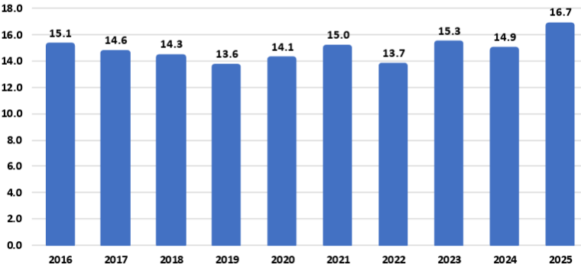
Source: USDA
For example:
The National Corn Growers Association (NCGA) is intensifying its call for action from Congress and the administration after the U.S. Department of Agriculture’s latest World Agriculture and Supply and Demand Estimates report projected a record 16.7-billion-bushel corn crop this year, further threatening the livelihood of farmers already facing record-low corn prices.
“Corn growers are already marketing their corn for extremely low corn prices, and this massive projected corn supply without market-based solutions to increasing corn demand is already causing corn prices to fall further,” said Illinois farmer and NCGA President Kenneth Hartman Jr. “Because we need markets fast for this supply, we are redoubling and intensifying our call for Congress to pass pending E15 legislation that will allow for year-round consumer access to higher blends of ethanol and for the Trump administration to quickly broker deals that will open new foreign markets for corn.”
Today’s WASDE report projects average corn yields of 188.8 bushels per acre for 2025, for an overall crop of 16.7 billion bushels. If the projections prove accurate, this year’s crop will be the largest on record by far: 1.4 billion bushels above the current production record set in 2023, a 9.1 percent increase.
An immediate boost to demand would be the passage of legislation authorizing year-round consumer access to 15 percent ethanol blend, or E15. This solution comes at no cost to consumers, requires no additional infrastructure developments and would generate demand for an additional 457 million bushels of corn, according to NCGA estimates.
NCGA is also pushing the administration to quickly broker additional deals with other countries and finalize details on deals already announced. For example, India, Vietnam and Kenya are all strategically important markets to U.S. corn growers.
Sen. Joni Ernst, R-Iowa, on July 31 introduced the Ethanol for America Act, a bill that aims to make it easier for Americans to fuel their vehicles with domestically produced E15. Companion legislation was introduced the following day by Rep. Adrian Smith, R-Neb.
The legislation would eliminate unnecessary barriers to E15 by requiring the U.S. EPA to finalize rulemaking from 2021 to make the E15 fuel label clearer and more consumer oriented. It would also confirm the compatibility of E15 with existing underground fuel storage and dispensing equipment.
Currently, fuel dispensers offering E15 must feature a label designed to alert customers to the appropriate and lawful use of the fuel. The proposed rule, issued in January 2021, co-proposes to either modify the E15 label or remove the label requirement entirely. The EPA opened a 90-day public comment period on the proposal but has failed to take final action on the rulemaking.
Following its introduction, the Senate bill, S. 2591, was referred to by the Senate Committee on Environment and Public Works. To date, Sens. Amy Klobuchar, D-Minn.; Deb Fischer, R-Neb.; Chuck Grassley, R-Iowa; Tammy Duckworth, D-Ill.; and Richard Durbin, D-Ill., have signed on to cosponsor the bill. The House bill, H.R. 4864, was referred to the House Committee on Energy and Commerce. Reps. Nikki Budzinski, D-Ill.; Dusty Johnson, R-S.D.; Tracey Mann, R-Kan.; Derek Schmidt, R-Kan.; Mike Flood, R-Neb.; Randy Feenstra, R-Iowa; and Brad Finstad, R-Minn., are cosponsoring the House bill.

Vietnam Opening Market to Ethanol
To boost ethanol imports from the U.S. tenfold to approximately 290 million gallons, the Vietnam Biofuel Association has proposed that the government swiftly implement a nationwide E10 biofuel gasoline program.
The Vietnam Biofuel Association recently submitted a document to the Domestic Market Management and Development Department (under the Ministry of Industry and Trade), addressing several issues related to the import tax on 99 percent ethanol used for biofuel blending, as well as the broader context of tariff negotiations and trade relations between Vietnam and the United States.
According to the association, the import tax on 99 percent ethanol - a type specifically used in biofuel gasoline blending - has continuously decreased from 15 percent to 12 percent, then 10 percent, and most recently to 5 percent. These reductions fall within the broader trade policy framework between Vietnam and the U.S.
Petrolimex and PVOIL, Vietnam’s two largest fuel distributors and retailers, launched the country’s first commercial trials of gasoline blended with 10 percent ethanol (E10) in three major cities last week. A total of 42 fuel stations in Hanoi, Ho Chi Minh City and Hai Phong began selling E10 RON95 gasoline as part of the trial that follows the Government of Vietnam’s recent announcement of a nationwide E10 mandate to begin in January.
“The U.S. Grains & BioProducts Council (USGBC) and its members and partners commend Petrolimex, PVOIL and the Government of Vietnam for advancing the use of fuel ethanol in Vietnam as a means to reduce harmful emissions, bolster fuel security and further stimulate rural economies,” said Ryan LeGrand, USGBC President and CEO. “This month’s rollout of E10 gasoline at retail stations is a massive step toward decarbonizing Vietnam’s transportation sector and a new potential partner for the U.S. ethanol industry and the American farmer.”
In 2018, Vietnam implemented an E5 mandate for its RON92 grade of gasoline, one of two gasoline grades widely used throughout the country. The Government of Vietnam’s decision to expand and migrate the country’s ethanol policy in 2026 to E10 and all grades of gasoline, including the more widely used RON95 grade, will help the Vietnamese fuel industry amplify the environmental and economic benefits of fuel ethanol use which augment Vietnam’s policy objectives.
Vietnam’s gasoline consumption surpassed 2.8 billion gallons in 2024, increasing 8.1 percent from 2023 consumption levels. A nationwide E10 mandate will create a total fuel ethanol demand of 280 to 300 million gallons per year, depending on gasoline demand.

USDA Land Value Report
The United States farm real estate value, a measurement of the value of all land and buildings on farms, averaged $4,350 per acre for 2025, up $180 per acre (4.3 percent) from 2024. The United States cropland value averaged $5,830 per acre, an increase of $260 per acre (4.7 percent) from the previous year. The United States pasture value averaged $1,920 per acre, an increase of $90 per acre (4.9 percent) from 2024.

Average Farm Real Estate Value (Dollars)
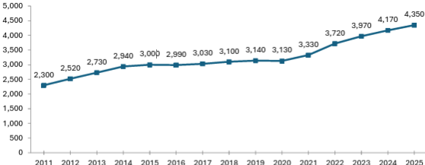
Source: USDA NASS

Farm Real Estate Value by State
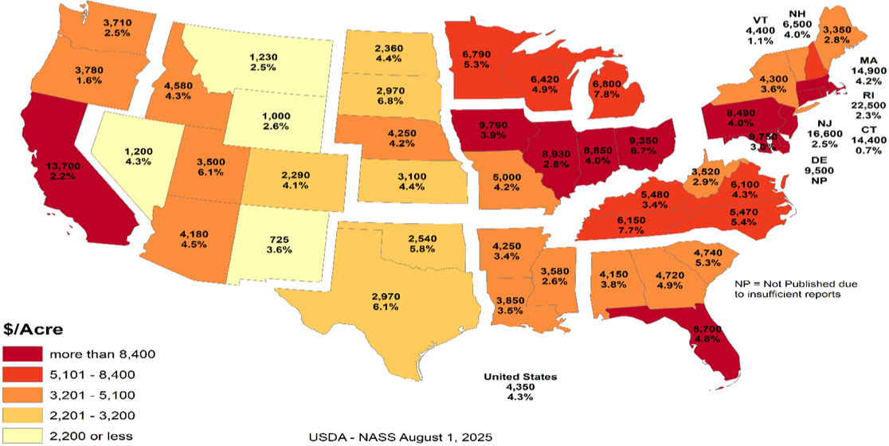
Like overall farm real estate values, average U.S. cropland values rose to record levels in 2025, reaching $5,830 per acre. This marks a 4.7 percent increase over 2024, nearly identical to the previous year’s growth but slower than the sharper increases earlier in the decade. In dollar terms, cropland values rose by $260 per acre year over year. Regional patterns remain consistent with broader farmland trends, with California and Northeastern states reporting the highest average cropland values. These are followed by much of the Midwest and Florida, the latter reflecting strong specialty crop production and ongoing residential development pressures. The top three states in percentage growth were Utah (9.7 percent), Michigan (8.2 percent) and Tennessee (7.8 percent). Notably, no states recorded a decline in cropland values.

Average Cropland Value (Dollars)
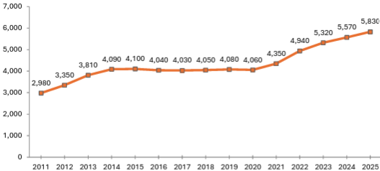
Source: USDA NASS

Cropland Value by State
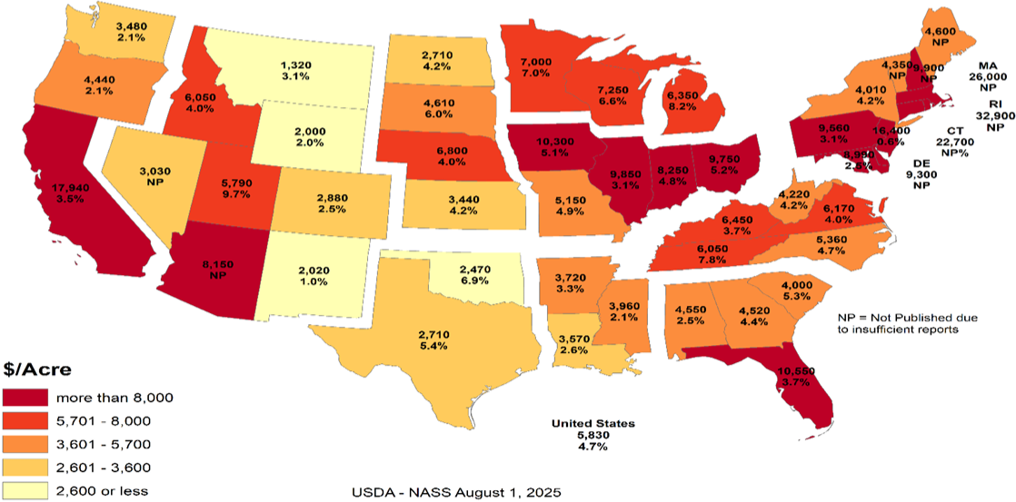
U.S. pastureland values continued their upward trend in 2025, rising to $1,920 per acre, a 5 percent increase over 2024. This growth is nearly in line with last year’s 5.2 percent gain but remains below the 6.7 percent increase in 2023 and the sharp 11 percent jump in 2022, which followed nearly a decade of stagnant values.
Unlike cropland and overall farm real estate, pastureland values are highest along the East Coast and mid-South, where development pressures, land scarcity and lifestyle demand contribute to elevated prices. In contrast, Western and Plains states report lower average values, partly due to lower land productivity and the prevalence of federally owned grazeable land accessed through grazing permits, which reduces market-based competition. In densely populated Eastern states, fragmentation of land and rising competition for open space (whether for grazing, recreation or rural living) continue to drive up per-acre costs for the limited private pastureland available.

Average Pasture Value (Dollars)
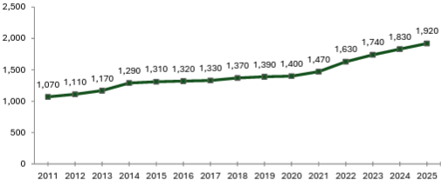
Source: USDA NASS

Pasture Value by State
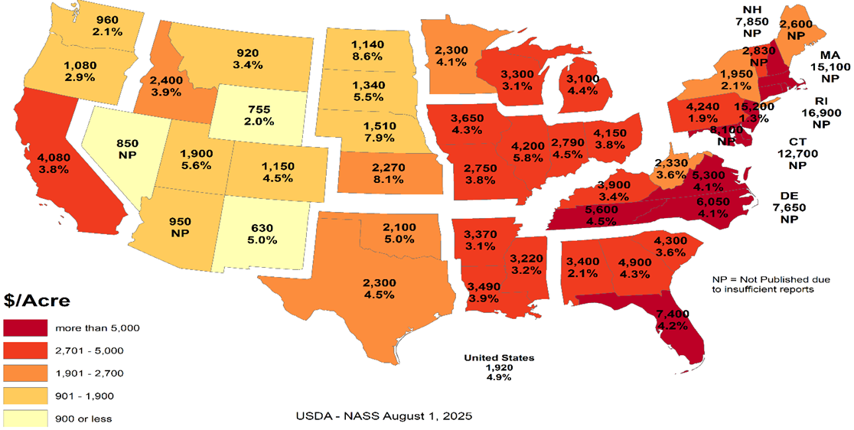

Cash Rents
American Farm Bureau summarized the USDA NASS cash rent survey.
NASS also released data on cash rents, which tend to lag changes in land values and commodity prices due to early-season lease negotiations. While the reported figures reflect past agreements, they often serve as important benchmarks for future producer-landlord negotiations, especially in areas with variable rent structures. Average U.S. cropland rent increased to $161 per acre in 2025, a modest 0.6 percent rise over 2024 — just $1 per acre. Irrigated cropland rents declined by 0.4 percent to $244 per acre, while non-irrigated rents rose 0.7 percent to $147 per acre. Pastureland cash rents remained unchanged at $15.50 per acre.
Despite minimal national movement, pressures on open land for solar development, suburban expansion and recreation continue to support rental rate growth in select areas, particularly where demand for working land is layered with lifestyle or energy investment interest. Increased telework continues to pull buyers and lessees into rural areas, intensifying local competition for land in certain high-amenity or fast-growing regions.
While earlier rent increases were tied closely to the 2021–2022 commodity price boom, today’s changes are more uneven, shaped by regional water constraints and shifting cropping patterns. In some areas, recent federal disaster assistance may have tempered pressure to renegotiate downward, even as commodity prices weaken and input costs remain high.

Cropland Cash Rent Value by State (Percent Change)
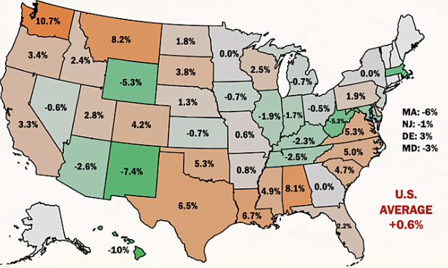
Source: American Farm Bureau, USDA NASS
Washington and Montana led the country in cropland cash rent growth, up 10.7 percent and 8.2 percent, respectively, followed by Alabama at 8.1 percent. Meanwhile, cropland rents in Hawaii, New Mexico, Wyoming, West Virginia and Massachusetts declined by more than 5 percent, likely due to a mix of stabilized drought conditions, changing land use priorities and rebalancing after years of sharp growth.
By value, the most expensive cropland rents remain in states with high-value specialty crops, such as California ($346/acre), Arizona ($334/acre) and Hawaii ($295/acre), often driven by contracts tied to irrigation infrastructure and water rights. Iowa, Illinois, Indiana and Washington round out the next tier of high-rent states, reflecting both row crop concentration and specialty crop presence. Water access and cost continue to be major drivers of both land value and rental rates across the Western U.S.
Margins for producers who rely heavily on rented land remain precarious, especially as revenue potentially slips while fixed costs (including rents) remain elevated or inflexible. Beginning farmers and those without land equity are especially exposed, facing steep barriers to accessing operating credit. In a year where net farm income is forecasted to decline without ad hoc support, even modest increases in rental rates can have outsized financial consequences.

Conclusion
Rural land values are experiencing a price bubble. In many of the Corn Belt states the cropland value continues to increase while the cash rent decreases. The values represent the impact of government land-based farm programs and ad hoc payment that could go to landowners. The government incentives to buy land have diminished the link between land values and real agricultural value. The result is farmers who rent land are increasingly in financial distress. As farmers exit the market, the disconnect between the land prices and cash rents will increase.
What the government gives it can take away. The Democrat party can win without the farm vote. Their messaging is trending away from “preserving family farmers” to “bashing Big Ag.” If rural land prices start declining, the floor is real agricultural value. For example, Illinois cash rent for cropland is $264 per acre. Farmdoc crop budget indicates that if a cash rent farmer needs $100 profit per acre to survive, the cash rent should be approximately $133 per acre or a decrease of approximately half. Assuming a 5 percent rate of return, the real agricultural value for cropland in Illinois is $2,660 per acre versus $9,850 per acre.
The other concern is that many of the new land buyers are investors. The investors are helping to drive land prices higher. When land values decrease, will the investors sit tight or take a profit? The investors do not have the same emotional attachment to the land. Farmers who want to own their own land act as a “put” under the land market. The good news is the farmers currently have low debt levels. This means the farmers have access to cash to buy land. The unknown is if the farmers are making a good investment or trying to catch a falling knife.

Cropland Cash Rent Value by State
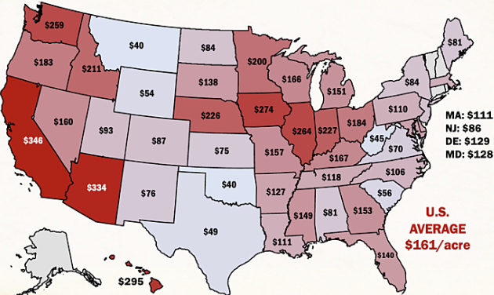
Source: American Farm Bureau, USDA NASS

Farmer Sediment
The Purdue University-CME Group Ag Economy Barometer index declined for the second month in a row. The July index fell 11 points below June’s reading and was fueled by U.S. farmers’ weaker perceptions regarding both current conditions and their expectations for the future. The July Current Conditions Index fell 17 points while the Future Expectations Index declined 7 points, both compared to a month earlier. Weaker income prospects in 2025 were largely responsible for farmers’ weaker appraisal of current conditions. Although all three principal farmer sentiment indices were lower in July than a month earlier, producer sentiment remains much more positive than at this time last year, with nearly three-quarters of July’s survey respondents reporting that the U.S. is headed “in the right direction.” The July barometer survey took place from July 7-11, 2025.
Concerns about weak income prospects in 2025 were evident in the July survey as the Farm Financial Performance Index fell 14 points compared to a month earlier. This month’s decline left the index at a reading of 90, indicating that more farmers expect weaker rather than stronger income in 2025 compared to 2024. Weakening crop prices are eroding income prospects. For example, in the Eastern Corn Belt, bids for fall harvest delivery of corn and soybeans were 7 percent and 3 percent lower during the July survey week, respectively, than just 4 weeks earlier. In turn, the decline in farmers’ income prospects helped push the Farm Capital Investment Index down 7 points in July to a reading of 53.

Farm Financial Performance Index
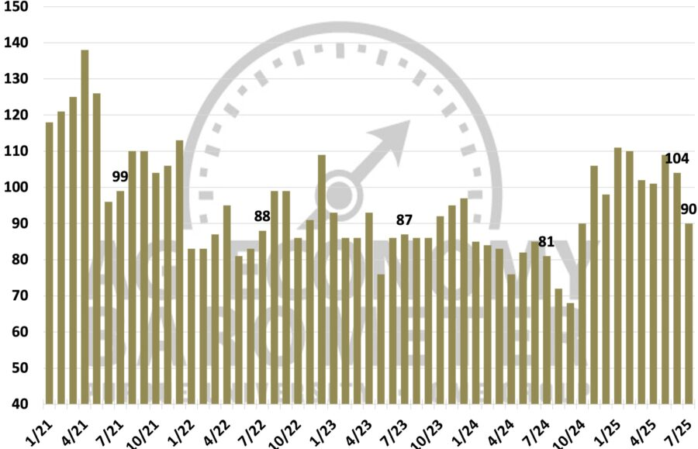
Source: Purdue/CME Group Ag Economy Barometer
Unsurprisingly, a weaker income outlook led to a softer outlook for farmland values in the upcoming year. The Short-Term Farmland Value Expectations Index dipped 5 points below a month earlier. This month’s reading of 115 also left the index 3 points lower than a year earlier and 10 points below two years ago. The farmland index’s weakness was attributable to a small shift among respondents away from expecting values to rise to looking for weakening values in the upcoming year, while the percentage expecting values to hold steady rose just one point to 57 percent. With farmland leasing discussions for next year underway between farmers and landowners, this month’s survey included a question regarding crop producers’ expectations for farmland cash rental rates in 2026. Despite weakening crop income prospects, nearly three-fourths (73 percent) of respondents said they expect cash rental rates in 2026 to remain about the same, with just 11 percent of crop producers indicating they expect rental rates to decline.
One supporting factor for both farmland values and farmland cash rental rates could be producers’ expectations regarding the farm income safety net provided by U.S. farm programs. In this month’s survey, 31 percent of respondents said they expect the safety net in the 2025 Farm Bill to be stronger than in the previous Farm Bill.
U.S. farmers in July were somewhat more optimistic about future agricultural trade prospects than a month earlier. This month, 43 percent of respondents said they expect agricultural exports to increase in the upcoming five years, up from 41 percent a month earlier. Fewer producers said they are looking for exports to decline, dropping to 13 percent of respondents, down from 16 percent who felt that way in June. In a related question, 64 percent of this month’s survey respondents said they think it likely that new foreign export markets will open to American agricultural goods in the next five years. To further gauge U.S. farmers’ outlook regarding trade and policy, this month’s survey included the following question: “Would you say things in the United States today are generally headed in the right direction or on the wrong track?” Seventy-four percent of respondents said the U.S. is headed in the “right direction.”
U.S. farmers’ sentiment declined in July as weaker farm income prospects dimmed producers’ view of current conditions and their future expectations. Despite a weaker crop income outlook, just 11 percent of crop producers said they expect farmland cash rental rates to decline, with a majority reporting that they expect rental rates to stay about the same. Helping to support producers’ farmland value and rental rate outlook is farmers’ expectation for a stronger farm income safety net, with nearly one-third (31 percent) of U.S. producers saying they expect the 2025 Farm Bill to provide a stronger safety net than the previous Farm Bill. Producers in July were somewhat more optimistic about U.S. agricultural trade prospects than in June, while nearly three-fourths (74 percent) of U.S. farmers responding to the survey reported that they feel that things in the U.S. are headed “in the right direction.”

Bunge Buys IFF Crush Division
As part of its second quarter results disclosure, International Flavors & Fragrances Inc. announced that it has entered into a definitive agreement to divest its soybean crush, concentrates, and lecithin business to Bunge Global S.A. The transaction includes operations that generated approximately $240 million in revenue in 2024 and employs around 250 people globally. The sale aligns with IFF’s strategy to strengthen its portfolio and supports the ongoing evaluation of strategic alternatives for its Food Ingredients segment, with a focus on maximizing shareholder value.

Greenhouse Gas Phase 3 Standards do not Apply to Human Health
The industry has an aftertreatment system for EPA's 2007 and 2010 Heavy-Duty Highway Engines and Vehicle emissions reduction regulations, which set standards for not only NOx but also particulate matter (PM). It also mandated the use of advanced emission control technologies like selective catalytic reduction (SCR) and diesel particulate filters. "Completely separate," said North American Council for Freight Efficiency Executive Director Mike Roeth. "Aftertreatment is not a direct GHG solution. We tend to call NOx and PM pollutant emissions, and they are directly attached to human health; breathing in these in the air... Carbon/GHG is different in that it affects climate, encouraging our more frequent and harsher weather events causing other health concerns."
Daimler Truck North America (DTNA) noted in a statement to Commercial Carrier Journal (CCJ) that the proposal does not modify EPA's existing requirements for criteria pollutants, including NOx and PM. NOx and PM standards remain in place, and they continue to be enforced independently of any changes to GHG regulations. "Selective Catalytic Reduction (SCR) systems, Diesel Exhaust Fluid (DEF), and aftertreatment technologies are essential components designed to reduce nitrogen oxides (NOx) regulated under the EPA's Clean Air Act," added Paccar companies Kenworth and Peterbilt. "The current aftertreatment systems related to NOx are still required to meet EPA and CARB standards and are independent of greenhouse gas (GHG) specific mandates."
Covered in the Endangerment Finding is nitrous oxide (N2O). NOx is shorthand for nitric oxide (NO) and nitrogen dioxide (NO2), the nitrogen oxides most relevant for air pollution. NOx itself is not considered a greenhouse gas; rather it plays a role in the formation of ozone, a naturally occurring greenhouse gas. Thus, NOx is not a greenhouse gas and the aftertreatment system, including DEF, would not be affected by this pending regulatory change.
However, EPA Administrator Lee Zeldin said in March his office intends to revisit portions of the Biden-era Clean Trucks Plan, which includes the 2022 Heavy-Duty NOx rule – a standard that includes new, more stringent emissions standards that cover a wider range of heavy-duty engine operating conditions and requires these more stringent emissions standards to be met for a longer period of time.

DEF Guidance Clarification
Starting in the early 2010s, regulations required all new on-road diesel vehicles, tractors, trucks, buses, ships, locomotives, gas turbines and construction equipment, to install additional technology to reduce nitrogen oxide emissions, a byproduct of diesel. Almost all commercial diesel transportation and equipment today has Selective Catalytic Reduction (SCR) technology that runs on DEF.
According to an EPA release, "EPA issued clear guidance urging engine and equipment manufacturers to revise DEF system software in existing vehicles and equipment to prevent these sudden shutdowns, giving operators more time to repair faults without impacting productivity or safety."
The EPA provided a chart showing derate timing for heavy duty trucks will be extended from a 5-mph limitation after just four hours' worth of a system fault to a three-stage derate:
- 15 percent torque reduction at 650 miles / 10 hours
- 30 percent torque reduction then at 4,200 miles / 80 hours
- and a final-stage derate to 25 mph at 8,400 miles / 160 hours
"In addition to providing certainty to manufacturers about how EPA wants this issue resolved, the agency is not requiring separate approvals beyond that provided in EPA’s guidance," the release said. "This ensures that bureaucratic steps do not delay manufacturers’ ability to put solutions into the field.”
Before the new EPA DEF guidance, a farmer had four hours before the vehicle or equipment stopped operating, leaving the farmer stranded. EPA’s new guidance to engine manufacturers will reduce derating, an automatic trigger forcing the engine to operate at a reduced capacity far below its capability and increase the amount of time operators must secure DEF and refuel.
Previously, farmers and truckers faced rapid engine slowdown to 5 mph within just four hours of a sensor alert. Under EPA’s new guidance for heavy-duty trucks, for example, after a fault is detected, only a warning light appears for 650 miles or 10 hours. Most significantly, there is no performance impact for at least one workday. Then, the engine only mildly derates by 15 percent, but this does not limit speed, allowing trucks to operate normally for up to 4,200 miles or two work weeks. Only after about four work weeks does speed drop to 25 mph until repairs are made. Most operators are expected to fix issues well before reaching this limit. Moving forward for farmers, non-road equipment will not experience an impact for the first 36 hours.
The ruling represents a major step up from the status quo by giving operators significantly more time to address faults before experiencing severe engine or speed limitations, which will improve their ability to complete daily operations and reduce downtime.
The revised DEF guidance is estimated to reduce farming expenses by $727 million annually. With fewer disruptions, reduced costs for emergency towing, repairs, rentals, DEF deliveries and inventories, producers will have greater operational and financial control.

Truck Manufacturers Sue CARB/California
Four of America’s top truck makers have officially filed a lawsuit in the U.S. District Court for the Eastern District of California challenging the Clean Truck Partnership (CTP) agreement signed with the California Air Resources Board in 2023. CARB has argued since the Congressional rollback of its Advanced Clean Trucks and Omnibus Low-NOx rules earlier this summer that despite the federal disapproval of the regulations, the CTP is still binding.
Cummins, Daimler Trucks North America, Hino, Isuzu, then-Navistar, Paccar, the Truck and Engine Manufacturers Association, and Volvo Group North America in July 2023 were among 11 signers of the CTP, an agreement with CARB that pledged truck and engine manufacturers will meet California’s vehicle standards and required the sale and adoption of zero-emission vehicle (ZEV) technology.
The OEMs said in the lawsuit that despite the Congressional Review Acts passed this year preempting California’s emissions standards, the state “continues to demand compliance with its heavy-duty emissions standards, and it has threatened OEMs that design, develop, manufacture and sell heavy-duty vehicles and engines ... with civil sanctions and unfavorable regulatory treatment if the OEMs refuse to comply with the state’s unlawful standards, while also taking measures to insulate itself from lawful challenges to those standards.”
Senior Clean Vehicles Advocate for the Natural Resources Defense Council Guillermo Ortiz called the lawsuit, "a cynical reversal of course. These companies helped negotiate the Clean Truck Partnership to secure regulatory certainty. Now they’re trying to dismantle the very deal they shaped -- injecting instability into a market they claim to lead," he said. "This is bad faith, plain and simple, and it raises questions about whether these manufacturers are serious about their ability to deliver clean trucks to the global stage."
The OEMs said the U.S. Department of Justice has sent them Cease & Desist letters stating that California’s enforcement of its regulations “is contrary to federal law” and directed the truck makers “to immediately cease and desist compliance with California’s preempted and unlawful mandates.”
This has left the OEMs “caught in the crossfire,” they said, as “California demands that OEMs follow preempted laws; the United States maintains such laws are illegal and orders OEMs to disregard them. This situation is not tenable.”
As such, the lawsuit aims to clarify the OEMs’ legal obligations under federal and state law and to block California from enforcing regulations that are preempted by federal law. Given the inconsistencies between federal and California regulatory requirements for emissions, truck and engine makers and their trade associations in 2023 petitioned CARB for relief from the state’s “infeasible regulatory requirements,” which resulted in the CTP, the lawsuit added. Now, according to the OEMs, “California seeks to use the Clean Truck Partnership, which was intended to harmonize compliance with state and federal law, to compel an entire industry to follow California emissions standards that are now in conflict with federal law, and which have been expressly preempted by federal law.” They added that the state is disregarding the CTP’s “plain language,” which “states that manufacturers are obligated to follow CARB’s emissions regulations ‘regardless of the outcome of any litigation challenging … those regulations, or CARB’s overall authority to implement those regulations,’ not federal legislative action taken to invalidate them.”
The regulatory back-and-forth between the federal government and California/CARB has put OEMs “in an impossible position,” they said in the lawsuit. “As a result, the OEMs are subject to two sovereigns whose regulatory requirements are irreconcilable and who are openly hostile to one another. Each wields a hammer to enforce its will on industry, leaving OEMs -- who simply seek to sell heavy-duty trucks in compliance with the law -- unable to plan with the necessary certainty and clarity where their products need to be certified for sale and by which regulatory authority.”
California, citing the CTP, has contended that in order for OEMs to legally sell trucks in the state, they must obtain certification from CARB. Yet the OEMs said this process “takes months,” adding that they “need to know within a matter of weeks whether they must obtain a model year 2026 certification from CARB in order to lawfully sell their products in California and other opt-in states, which together represent approximately 25 percent of the national market for new vehicle registrations for heavy-duty vehicles.”
In filing the lawsuit, the truck makers said they are looking for “declaratory and injunctive relief with the goal of clarifying and establishing the regulatory obligations that they must follow to lawfully offer products for sale in California and the various opt-in states, and to prevent California officials from violating their constitutional rights,” adding that “an expeditious decision is essential.”
The OEMs’ lawsuit joins another suit brought by the Western States Trucking Association that challenged CARB’s authority to enforce the CTP following the federal preemption of the regulations.

Ambassador Jamieson Greer: Why We Remade the Global Order
The following op-ed provides the foreign policy vision of the Trump Administration. On the 200-day mark of the second Trump administration, United States Trade Representative Jamieson Greer published an op-ed in The New York Times explaining how President Trump’s trade policy is remaking the international economic order to reduce our trade deficit and deliver lasting benefits for American workers and industries.
The full text of the op-ed is below:
It must be an unwritten rule that international economic orders emerge at stately hotels. In 1944, as World War II raged, Allied representatives gathered at a picturesque New Hampshire resort named Bretton Woods to discuss how to establish a postwar economic order to restore the sensible flow of trade in a fractured world.
Although the resulting Bretton Woods system ended in 1976, its legacy lives on. Our current, nameless global order, which is dominated by the World Trade Organization and is notionally designed to pursue economic efficiency and regulate the trade policies of its 166 member countries, is untenable and unsustainable. The United States has paid for the system with the loss of industrial jobs and economic security, other countries have been unable to make needed reforms, and the biggest winner has been China, with its state-owned enterprises and five-year plans. Unsurprisingly, the past decade has seen significant international and bipartisan American frustration at the system’s failure to adapt to meet the essential interests of sovereign nations.
Now, reform is at hand. Last week at his Turnberry resort on the Scottish coast, President Trump and the European Commission president, Ursula von der Leyen, concluded a historic agreement — one that is fair, balanced and oriented toward serving concrete national interests rather than vague aspirations of multilateral institutions. Indeed, by using a mix of tariffs and deals for foreign market access and investment, the United States has laid the foundation for a new global trading order.
The previous system rejected tariffs as a legitimate tool of public policy, meaning that the United States sacrificed tariff protection for critical manufacturing and other sectors. Over the past three decades, the United States slashed barriers to our market to allow vast inflows of foreign goods, services, labor and capital. At the same time, other countries kept their markets closed to our goods and deployed a suite of policies — such as subsidies, wage suppression, lax labor and environmental standards, regulatory distortions and currency manipulation — to artificially boost exports to the United States. This approach made the United States and a handful of other economies the consumers of last resort for countries pursuing beggar-thy-neighbor economic policies.
Our trading partners were adept at this game, and elites on Wall Street and in Washington were all too happy to cash in on the global arbitrage by moving production abroad. The net result? The bulk of global manufacturing shifted to jurisdictions such as China, Vietnam and Mexico where companies could exploit vulnerable workers or benefit from expansive state support while the United States ran up what in absolute terms is the highest trade deficit in the history of the world. This led to extensive and well-documented losses in U.S. industrial capacity and employment as well as reliance on our adversaries for critical supply chains.
We subordinated our country’s economic and national security imperatives to a lowest common denominator of global consensus. This approach harmed American workers, their families and communities by undermining a manufacturing sector that creates high-wage jobs, fosters innovation and catalyzes investment across the economy.
What began at Bretton Woods as a necessary effort to rebuild a global trade system shattered by war evolved, over nine rounds of trade negotiations, into something unrecognizable. The measured guidelines for commerce developed in the Kennedy and Tokyo Rounds gave way to our recent experiment in global hyper-integration, embodied in the Uruguay Round, which concluded in 1994 and established the W.T.O.
We are now witnessing the Trump Round. On April 2, President Trump announced tariffs to address the national emergency posed by the trade deficit. The intense bilateral negotiations that followed were held in diverse locations across the world: Washington, Geneva, Jeju Island, Paris, London, Stockholm and, of course, Turnberry. Our trading partners had never before shown such interest in opening their markets to the United States, aligning on matters of economic and national security, and rebalancing trade in a more sustainable direction. In a few short months, the United States secured more foreign market access than it had in years of fruitless W.T.O negotiations.
Reversing decades of harmful policy that weakened our manufacturing capacity and work force will take time and coordinated effort across the public and private sectors. But keeping the status quo would only accelerate the dangerous trajectory of deindustrialization. We require a generational project to re-industrialize America, and time is short.
When I joined a critical mass of my fellow trade ministers in June at a meeting of the Organization for Economic Cooperation and Development in Paris, I was struck by how many voiced serious concerns about the danger of macroeconomic imbalances, the threat of nonmarket practices and the sclerotic state of the global trading system — the same issues President Trump has raised for years and now taken emergency action to address. What was long dismissed as heresy by the free-trade fundamentalists in Brussels, Geneva and Washington is now becoming conventional wisdom.
In announcing the U.S.-European Union deal last week, President von der Leyen echoed the call to refashion global trade to adapt to economic and political realities. She explained to reporters that the trans-Atlantic economic relationship needed “rebalancing” to ensure that it could be “more sustainable.” Such recognition is reinforced by additional deals with Britain, Cambodia, Indonesia, Japan, Malaysia, Pakistan, the Philippines, South Korea, Thailand and Vietnam, which make up almost 40 percent of U.S. trade, according to my office’s figures. Other countries with large trade surpluses with the United States are subject to generally higher tariffs. The new economic order, solidified at Turnberry, is emerging in real time.
The results are astounding. Every year for 40 years, the Office of the U.S. Trade Representative has produced a detailed report called the National Trade Estimate chronicling various barriers faced by U.S. companies, including high tariffs, requirements to produce goods in the countries where the companies want to do business, and restrictions on agricultural products contrary to scientific consensus. In the past, the only significant way the United States could remove these barriers (if at all) was by giving away the tariffs defending our manufacturing sector. President Trump has flipped the script on this: Now, we are systematically eliminating these barriers abroad while ensuring sufficient tariff protection at home.
Indonesia is lowering 99.3 percent of its tariffs on imports from the United States and eliminating a slew of longstanding non-tariff barriers, while accepting a 19 percent tariff on exports to the United States. South Korea is accepting U.S. auto standards along with a 15 percent tariff. Vietnam pledged to lower all of its tariffs and barriers in exchange for a 20 percent rate. Most countries we are negotiating with have also agreed to cooperate on economic security to ensure the safety and reliability of our critical supply chains.
Countries are also committing to upgrade and better enforce their labor standards, tackling arbitrages that have put American workers and producers at a disadvantage. Multiple countries will join the United States (along with the E.U., Mexico and Canada) in banning the importation of goods made with forced labor. Eliminating global slavery was a longstanding goal of advocates and policymakers, but it was the leverage of President Trump’s tariffs that finally made it possible to unlock meaningful progress.
Similarly, countries are agreeing to improve resource efficiency and enforcement of environmental laws, including in the most problematic sectors, such as illegal logging, illegal fishing and the illegal wildlife trade. The international trade system should not force Americans to compete with those who use our responsible capitalism against us as a competitive advantage.
Importantly, these commitments are actionable, and the United States will enforce them. Rather than the drawn-out dispute settlement process favored by the old guard of trade bureaucrats, the new U.S. approach is to closely monitor implementation of the deals and swiftly reimpose a higher tariff rate for noncompliance if needed. President Trump uniquely recognizes that the privilege of selling into the world’s most lucrative consumer market is a mighty carrot. And a tariff is a formidable stick.
At the World Trade Organization, enacting changes to trade rules requires total consensus among nations. In fact, the last attempt at serious reform, known as the Doha Round, failed because protectionist nations refused to take down their trade barriers to the United States. Moreover, our adversaries relish blocking reform. They prefer a status quo that feeds an exploding U.S. trade deficit, sapping this nation of the industrial might that made it, and keeps it, a superpower.
But the rules of international trade cannot be a suicide pact. By imposing tariffs to rebalance the trade deficit and negotiating significant reforms that form the basis of a new international system, the United States has shown bold leadership to address what policymakers long considered intractable problems.
Many of these deals also come with significant investment commitments into U.S. productive capacity, such as $600 billion in the case of the European Union and $350 billion by South Korea. These investments — 10 times larger than the inflation-adjusted value of the Marshall Plan that rebuilt Europe after World War II — will accelerate U.S. reindustrialization. South Korea will help reinvigorate the American shipbuilding industry, which has atrophied in the face of nonmarket competition. These types of investments are on top of purchase commitments that cumulatively account for almost $1 trillion of American energy, agriculture, defense and industrial products. This demand for American goods and ready access to capital will allow American manufacturing to reassert leadership across strategic sectors where we have fallen behind.
Skeptics point out that tariffs, although once a fixture of American economic policy, have not been used this extensively for generations. But we now have data showing that the failure to use tariffs or similar protections created an economy that was heavy on finance and consulting fees and low on the lasting wealth and security that come from making things. Even among those who agree with that diagnosis, some say the president’s remedy is too strong or was administered too hastily, or that the tariffs will be too disruptive in the short term. This is not the time to debate how many angels can dance on the head of a pin. This is an emergency. We know what the problem is and we know how to address it. There is no time to waste.
President Trump has already shown that he can implement tariffs and other economic tools to reshape supply chains and reinvigorate manufacturing. When he deployed sweeping tariffs in his first term, not only did the sky not fall as pundits predicted, but inflation actually went down. And now that he is imposing tariffs even more broadly, inflation remains in check. A long-term problem won’t be fixed overnight, and the process may not always be smooth, but the situation demands strong and resolute action to strengthen the U.S. industrial base.
It took over 50 years from that first meeting at Bretton Woods until the creation of the W.T.O. It has been 30 years since. Fewer than 130 days from the beginning of the Trump Round, the Turnberry system is by no means complete, but its construction is well underway.

Stagflation Discussion
Stagflation talk has taken center stage. It should be remembered that stagflation in the 1970s was driven by crude oil prices increasing from $3.56 per barrel in August 1973 to $10.11 per barrel in January 1974 to $14.85 per barrel in January 1979 to $39.50 per barrel in May 1980. In less than seven years crude oil price increased by over 1,100 percent. By comparison, the current crude oil price is approximately half the May 2022 price. With almost every country expanding energy production, lower energy prices could occur.
According to the prolonged price decrease in crude oil and natural gas, inflation numbers will be below macro-economic models. This is because energy is incredibly important as it impacts inflation numbers directly, such as fuel and as a feedstock in petrochemicals, and indirectly, such as an increased cost that a manufacturer and business must recoup. Energy costs impact input prices for production, and every other stage required to reach the consumer with each cost increase being pushed to the next level. The cumulative impact of higher energy prices on the consumer tends to be understated by macro-economic models.
One inflationary outcome from lower energy prices is discretionary income increasing, which allows for more spending. The other outcome is the producer price index will show a decline with retail sales prices staying firm and retailers performing better than if it was still a higher energy cost environment. Any economic downturn will force retailers to lower prices to move products.
The inflationary impact of the massive increase in the money supply has worked its way through the economy, resulting in a natural slowdown. It is difficult to have runaway inflation with lower energy prices, and a weak housing market.
During the last trade war, the rate of inflation decreased. It is not a forgone conclusion that the rate of inflation is going to increase. The consumer price index increased a seasonally adjusted 0.2 percent for the month and 2.7 percent on a 12-month basis, the Bureau of Labor Statistics reported. That compared with the respective Dow Jones estimates for 0.2 percent and 2.8 percent.
Excluding food and energy, the core CPI increased 0.3 percent for the month and 3.1 percent from a year ago, compared with the forecasts for 0.3 percent and 3 percent. Federal Reserve officials generally consider core inflation to be a better reading for longer-term trends. The monthly core rate was the biggest increase since January while the annual rate was the highest since February.
Tariff-sensitive new vehicle prices also were unchanged. For now, automakers are choosing to keep market share.
A 0.2 percent increase in shelter costs drove much of the rise in the index, while food prices were flat and energy fell 1.1 percent, the BLS said. U.S. housing market now 508,715 more home sellers than homebuyers. With the current housing market experiencing pain, it is easier to envision lower prices not higher prices.

U.S. Consumer Price Index (Annual Change)
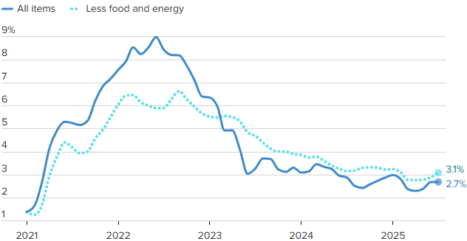
Crude Oil $120 per barrel
Source: BLS, CNBC

Estimated Number of Homebuyers and Sellers
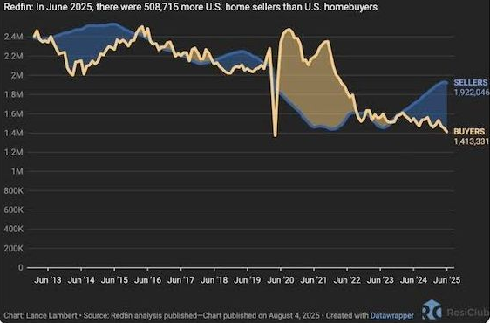

Mid-America Manufacturing Slumps for July
After six straight months of above growth neutral readings, the Creighton University Mid-America Business Conditions Index, a leading economic indicator for the nine-state region stretching from Minnesota to Arkansas, sank below 50.0 growth neutral threshold for July.

Overall Index
The Business Conditions Index, which uses the identical methodology as the national Institute for Supply Management (ISM) and ranges between 0 and 100 with 50.0 representing growth neutral, declined to 49.4 for July from 50.7 in June.
“Creighton’s latest survey continues to reflect job losses across the region, accompanied by elevated wholesale inflation,” said Ernie Goss, PhD, Director of Creighton University’s Economic Forecasting Group and the Jack A. MacAllister Chair in Regional Economics in the Heider College of Business. “Supply managers expressed growing concern that rising tariffs could further accelerate inflationary pressures. Despite these concerns, only 6.7 percent of surveyed supply managers reported shifting purchases from international to domestic suppliers in response to the tariffs.”

Employment
The July employment index fell to 45.4 from 49.4 in June, marking the fourth consecutive month below the growth-neutral threshold of 50. This sustained weakness reflects ongoing labor market challenges in the regional manufacturing sector.
“The Creighton survey has now recorded six straight months of job losses across the nine-state Mid-America region,” said Goss. “While employment rose in the first quarter—driven by increased production ahead of anticipated tariff impacts—the last four months have signaled a return to regional manufacturing job declines,” said Goss.
U.S. Bureau of Labor Statistics data show that the region shed 12,900 (-0.9 percent) manufacturing jobs over the past 12 months. The U.S. lost 89,000 (-0.7 percent) manufacturing jobs over the same time period.
Comments from Supply Managers in July:
- “Most of the suppliers I work with are dropping their production down to four-day work weeks. Nothing like a 20 percent cut in pay.”
- “I believe that the President's tariff changes are going to help our country to be better trading partners. It will take a bit of time for it all to shake out though.”
- “No changes to international purchases until a final tariff rate is in place. Certain products have been put on hold.”
- “We are not accepting pricing increases and have any tariffs added as a surcharge, so they are easy to remove.”
- “Long-term contracts have been key to holding pricing steady. Where there are extreme cost pressures with suppliers, collaboration on a resolution is the method of choice, while rare.”
- “While the Trump administration is doing everything possible to bring the economy back to its former glory, the democrats continue their seditious acts to block any attempts at dismantling their previous criminal maneuvers to destroy this great country! A reckoning is coming.”

Wholesale Prices
The July price gauge climbed to 69.7 from 67.9 in June. “The regional inflation yardstick has moved into a range indicating that inflationary pressures are moving higher at the wholesale level. However, due to a slowing regional and U.S. economies, I expect the Federal Reserve to cut interest rates at its September 16-17 meetings,” said Goss.
On average, supply managers expect tariffs to push input prices up by 7.8 percent over the next 12 months. This is up from 7.5 percent recorded in June.

Confidence
Looking ahead at the next six months, economic optimism, as captured by the July Business Confidence Index, dropped to 42.6 from June’s 50.0. “Concerns regarding tariffs and slowing new orders pushed supply managers’ expectations lower. Only one in six supply managers expect rising economic conditions for their firm over the next six months,” said Goss.

Inventories
The regional inventory index, reflecting levels of raw materials and supplies, increased to 49.1 in July from June’s 46.9. “Rapid expansions in inventories in the first quarter are now being offset by monthly pullbacks in buildups,” said Goss.

Trade
Recent uncertainty regarding tariffs and trade restrictions pushed new export orders lower for the last four months. New export orders slumped to 38.3 from 43.4 in June. As a result of record imports for the first two months of 2025, supply managers pulled back on purchasing from abroad in the last five months. The July import index increased to a still weak reading of 36.3 from 30.0 in June.
Supply managers were asked about their firm’s reactions to tariffs and threats of tariffs. Only 6.7 percent of manufacturing supply managers reported switching from international suppliers to domestic suppliers. More than one-third, or 67.0 percent, reported making no changes of suppliers due to tariffs. The remaining 26.3 percent indicated that their firms had switched from one international supplier to another international input supplier.
According to U.S. International Trade Administration (ITA) data, the regional economy exported $38.9 billion in manufactured goods for the first five months of 2025, compared to $40.8 billion for the same period in 2024, for a 4.7 percent decline. In terms of export gainers, North Dakota registered the top percentage gain with a 42.6 percent addition, and South Dakota recorded the largest percentage loss with a 19.9 percent reduction in the export of manufactured goods.

Other Survey Components of the July Business Conditions Inde
New orders dropped to 45.5 from 52.4 in June; the production or sales index increased slightly to 49.0 from 48.5 in June; and the speed of deliveries of raw materials and supplies rose to 57.8 from June’s 56.5. Higher readings indicate slower deliveries and/or rising supply chain disruptions or delays.

Arkansas
The state’s July Business Conditions Index fell to 43.0 from 48.2 in June. Components from the July survey of supply managers were new orders at 43.7, production or sales at 47.0; delivery lead time at 53.1; inventories at 39.5; and employment at 31.8. According to ITA data, the Arkansas manufacturing sector exported $2.3 billion in goods for the first five months of 2025, compared to $2.4 billion for the same period in 2024, for a 5.6 percent decline.

Iowa
The state’s Business Conditions Index for July declined to 43.7 from 48.0 in June. Components of the overall July index were new orders at 43.9; production or sales at 47.3; delivery lead time at 53.6; employment at 33.2; and inventories at 40.6. According to ITA data, the Iowa manufacturing sector exported $6.2 billion in goods for the first five months of 2025, compared to $6.9 billion for the same period in 2024, for a 10.3 percent decline.

Kansas
The Kansas Business Conditions Index for July increased to 51.1 from 49.9 in June. Components of the leading economic indicators from the monthly survey of supply managers for July were new orders at 45.5; production or sales at 50.3; delivery lead time at 58.6; employment at 47.7; and inventories at 58.6. According to ITA data, the Kansas manufacturing sector exported $5.0 billion in goods for the first five months of 2025, compared to $5.2 billion for the same period in 2024, for a 3.5 percent decline.

Minnesota
The July Business Conditions Index for Minnesota dropped to 49.3 from 52.8 in June. Components of the overall July index were new orders at 45.1; production or sales at 49.8; delivery lead time at 57.5; inventories at 50.2; and employment at 44.3. According to ITA data, the Minnesota manufacturing sector exported $9.5 billion in goods for the first five months of 2025, compared to $10.7 billion for the same period in 2024, for an 11.4 percent decline.

Missouri
The state’s July Business Conditions Index rose to 51.8 from 50.8 in June. Components of the overall index from the survey of supply managers for July were new orders at 45.6; production or sales at 50.6; delivery lead time at 59.1; inventories at 54.4; and employment at 49.2. According to ITA data, the Missouri manufacturing sector exported $7.0 billion in goods for the first five months of 2025, compared to $7.1 billion for the same period in 2024, for a 0.5 percent decline.

Nebraska
The state’s July Business Conditions Index climbed to 51.6 from June’s 51.3. Components of the index from the monthly survey of supply managers for July were new orders at 45.5; production or sales at 50.4; delivery lead time at 58.8; inventories at 53.6; and employment at 48.3. According to ITA data, the Nebraska manufacturing sector exported $2.7 billion in goods for the first five months of 2025, compared to $3.1 billion for the same period in 2024, for a 10.8 percent decline.

North Dakota
The state’s Business Conditions Index advanced above growth neutral for a 13th consecutive month to 52.2 from 52.0 in June. Components of the overall index for July were new orders at 45.7; production or sales at 50.8; delivery lead time at 59.4; employment at 50.0; and inventories at 55.0. According to ITA data, the North Dakota manufacturing sector exported $2.5 billion in goods for the first five months of 2025, compared to $1.8 billion for the same period in 2024, for a 42.6 percent gain.

Oklahoma
The state’s Business Conditions Index for July declined to 49.0 from 50.6 in June. Components of the overall July index were new orders at 45.0; production or sales at 49.5; delivery lead time at 57.2; inventories at 49.7; and employment at 43.7. According to ITA data, the Oklahoma manufacturing sector exported $2.9 billion in goods for the first five months of 2025, compared to $2.6 billion for the same period in 2024, for a 3.5 percent gain.

South Dakota
The July Business Conditions Index for South Dakota slumped to 44.5 from 48.5 in June. Components of the overall July index were new orders at 44.1; production or sales at 47.6; delivery lead time at 54.1; inventories at 42.1; and employment at 34.8. According to ITA data, the South Dakota manufacturing sector exported $0.7 billion in goods for the first five months of 2025, compared to $0.9 billion for the same period in 2024, for a 19.9 percent decline.

Corn
Fundamental Recommendation: Corn has traded toward the upper end of the recent range as seasonal strength and early South American weather concerns support the market. However, with global stocks expected to rebuild and U.S. export competitiveness constrained, rallies are likely to fade. Sell any contract above $4.85, particularly July 2026, as the forecast projects prices peaking near $4.90 before easing into the second half of 2026.

Fundamental Bullish Factor – Despite the lack of official USDA data in prior weeks, weekly ethanol corn grind has remained robust, tightening traders’ expectations for U.S. stocks-to-use ratios.
Fundamental Bullish Factor – Cattle margins remain historically high, and competition from Argentine imports will likely accelerate the recovery in the cattle cycle, supporting additional feed demand..
Fundamental Bearish Factor – The return of USDA data may shift market attention back toward ample global supply, after several weeks in which sentiment was driven primarily by demand indicators.
Fundamental Bearish Factor – The U.S. remains uncompetitive in export markets, with Brazil and Argentina offering more attractive corn to global buyers.
Fundamental Swing Factor – Potential revisions to U.S. biofuel policy and the development of SAF technology.
Fundamental Swing Factor – Changes in U.S. export competitiveness as the South American seasonal export window begins to close.

Technical Recommendation: Sideways to Lower.

Technical Bullish Factor – Relative strength index is oversold and at levels that have indicated price bottoms in the past.
Technical Bullish Factor – Solid chart support just below present prices.
Technical Bullish Factor – Massive crop overwhelming technicals.
Technical Bearish Factor – Prices still in downtrend in place on daily bar chart.
Technical Bearish Factor – Prices well below key 40-day moving average.
Technical Bearish Factor – Longer-term price charts are bearish.
Corn (continued)

CBOT Corn Technicals
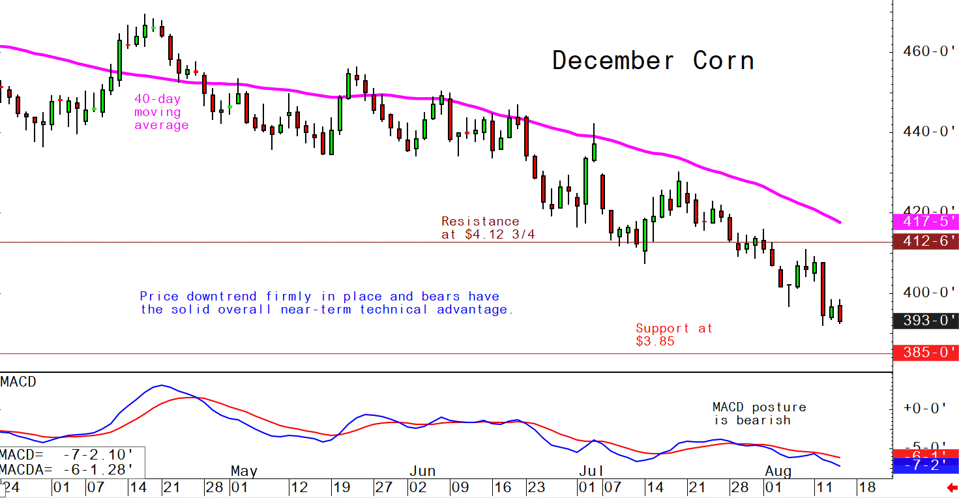
Wheat
Fundamental Recommendation: Wheat has entered a period when the market typically prices in a weather-risk premium, but fundamentals remain heavy with large global ending stocks and strong Russian exports. The forecast peaks near $5.50/bu for July 2026 before trending lower into September. With the balance sheet still ample and global competition limiting U.S. upside, sell any contract above $5.50, as short-term weather volatility is unlikely to offset the broader downtrend expected over the next year.

Fundamental Bullish Factor – Growing concerns about dryness in Hard Red Winter wheat growing areas in the US
Fundamental Bullish Factor – Continued tensions and war in the Black Sea region limiting export volumes
Fundamental Bearish Factor – Global ending stocks remain burdensome despite uncertainty around next year’s U.S. crop.
Fundamental Bearish Factor – Increased competition for feed from corn (energy) and protein meals due, in part, to record US oilseed crushing volumes
Fundamental Swing Factor – Any change in the competitiveness of feed wheat in world rations as relative prices adjust.
Fundamental Swing Factor – Reports of modest Chinese purchases of U.S. wheat may slightly improve U.S. export competitiveness, but volumes remain too small to shift the broader balance sheet.
Technical Recommendation: Sideways to Lower.

Technical Bullish Factor – Markets are short-term oversold and due for upside correction.
Technical Bearish Factor – SRW and HRW prices well below key 40-day moving averages.
Technical Bearish Factor – SRW and HRW prices in downtrends on daily charts.
Technical Bearish Factor – Down-trending corn market is bearish for wheat.

Wheat (continued)

CBOT Wheat Technicals
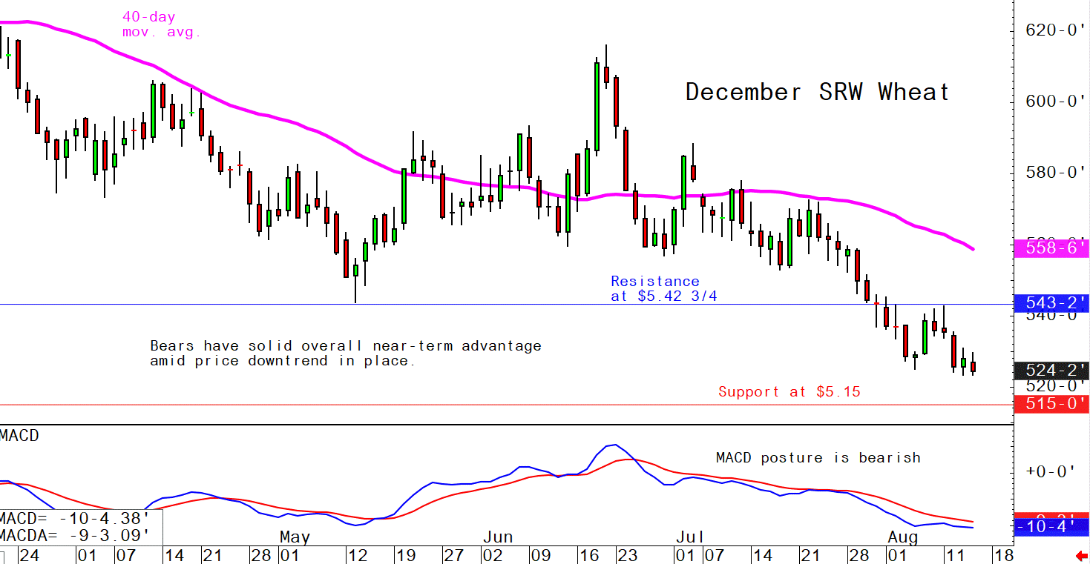

Soybeans
Fundamental Recommendation: Soybean futures firmed on renewed Chinese buying interest, but the market now faces a more balanced narrative as planting across Brazil progresses at a normal pace and weather remains mostly favorable. With USDA data returning and reinforcing expectations for ample global supply, upside remains limited. The forecast suggests prices peaking near $11.70/bu by mid-2026 before easing toward $11.00/bu into late year. Sell any contract above $11.70, as gains are likely to be short-lived unless new weather stress develops later in the season.

Fundamental Bullish Factor – Seasonal positioning keeps a modest weather-risk premium in place, even as conditions have improved across most growing regions.
Fundamental Bullish Factor – Continued robust global crush demand, supported by strong protein-meal usage.
Fundamental Bearish Factor – With USDA data returning, the market may shift away from the recent demand-driven narrative and refocus on large global supply, which is likely to limit rallies as South American planting advances.
Fundamental Bearish Factor – Favorable conditions across Brazil and Argentina, with sowing on pace or ahead of averages, continue to ease early-season production concerns.
Fundamental Swing Factor – Ongoing South American weather trends will determine whether the current risk premium persists or fades.
Fundamental Swing Factor – The performance of Chinese imports versus commitments remains critical for U.S. export sentiment.

Technical Recommendation: Sideways.

Technical Bullish Factor – Prices now above key 40-day moving average.
Technical Bullish Factor – Soybean meal market now performing much better.
Technical Bullish Factor – MACD indicator turns bullish.
Technical Bearish Factor – Slumping corn and wheat markets are bearish for beans.
Technical Bearish Factor – Longer-term charts are not friendly for beans.

Soybeans (continued)

CBOT Soybeans Technicals
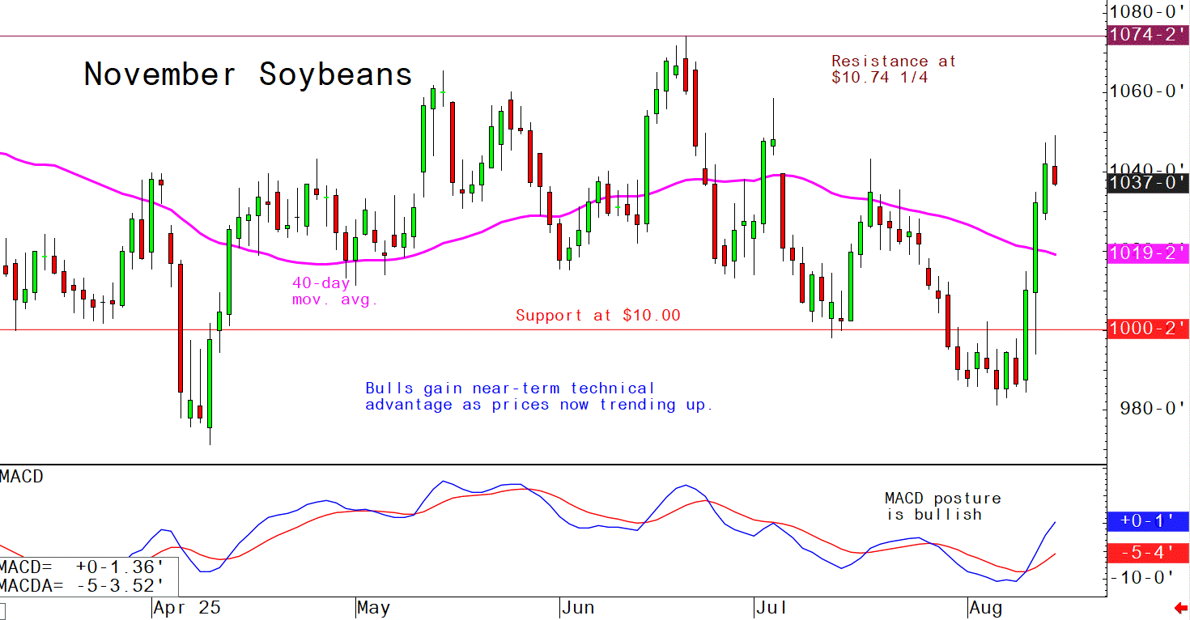
Soybean Meal
Fundamental Recommendation: Soybean meal prices are expected to strengthen modestly through early 2026, with the forecast peaking near $360/short ton before trending lower into the second half of the year. Strong domestic and global demand for protein meals continues to provide support, even as record U.S. crush expands supply. With sulfur-containing feed alternatives (DDGS) rising alongside ethanol production, the market should soften later in the year. Sell any contract above $355, as midyear highs are likely to fade into late 2026.
Fundamental Bullish Factor – Strong meal demand continues to anchor the market, supported by firm protein-feed usage across livestock sectors globally.
Fundamental Bullish Factor – With biofuel mandates not accelerating meaningfully, oil-driven crush incentives are weaker, placing relatively more strength behind meal fundamentals in the near term.
Fundamental Bearish Factor – Growing competition from DDGS and other feed alternatives as ethanol output holds steady.
Fundamental Bearish Factor – Seasonal Argentine export competition expected to intensify into early 2026 as their crop advances, adding downward pressure later in the season.

Technical Recommendation: Sideways to Higher.

Technical Bullish Factor – Prices now trending up on daily bar chart.
Technical Bullish Factor – Prices above key 40-day moving average.
Technical Bullish Factor – Spreaders are unwinding short meal, long bean oil spreads.
Technical Bearish Factor – Market is short-term overbought, technically.
Technical Bearish Factor – Longer-term charts are not bullish.

Soybean Meal (Continued)

CBOT Soybean Meal Technicals
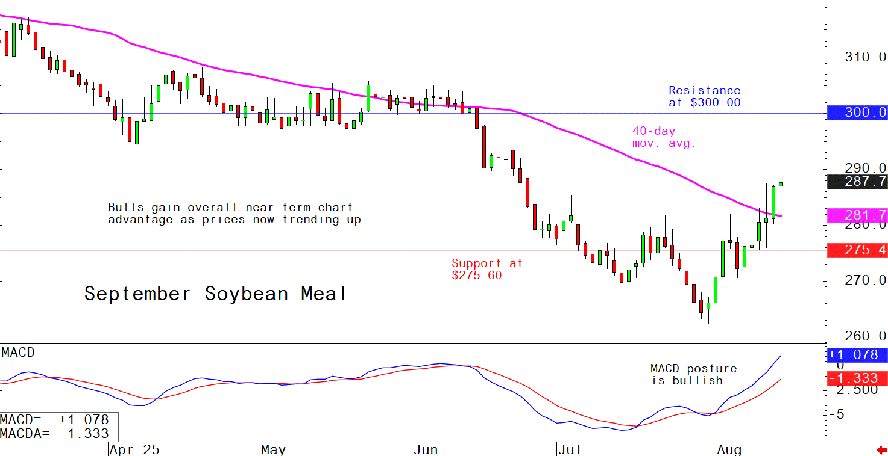

Soybean Oil
Fundamental Recommendation: Soybean oil prices are expected to trend higher through 2026, with the forecast rising from around 52¢/lb early in the year to near 56¢/lb by late 2026. Steady renewable diesel demand and tightening global vegetable oil balances provide underlying support. With futures still trading below the projected curve, buy any contract below 52¢, targeting the mid-50¢ range as the market aligns with stronger biofuel fundamentals.
Fundamental Bullish Factor – Structural renewable diesel demand keeps soybean oil embedded as a key feedstock, maintaining a long-term upward pull on usage.
Fundamental Bullish Factor – Persistent tightness in palm oil markets, supported by steady biodiesel mandates in major producing countries, continues to underpin the broader vegetable oil complex.
Fundamental Bearish Factor – delays in Brazil’s biofuel mandate implementation and the lack of upward revisions in U.S. biofuel volumes soften near-term demand for soybean oil.
Fundamental Bearish Factor – Mandate uncertainty adds pressure to oil-driven crush margins, keeping crushers cautious and reducing the near-term pull from the renewable diesel and SAF sectors.

Technical Recommendation: Sideways to Lower.

Technical Bullish Factor – Solid chart support levels just below the market.
Technical Bullish Factor – Rallies in soybeans and meal will limit downside in bean oil.
Technical Bullish Factor – Weekly chart is still friendly.
Technical Bearish Factor – Price downtrend in place on daily chart.
Technical Bearish Factor – Prices below key 40-day moving average.
Technical Bearish Factor – Slumping crude oil prices bearish for bean oil.

Soybean Oil (Continued)

CBOT Soybean Oil Technicals
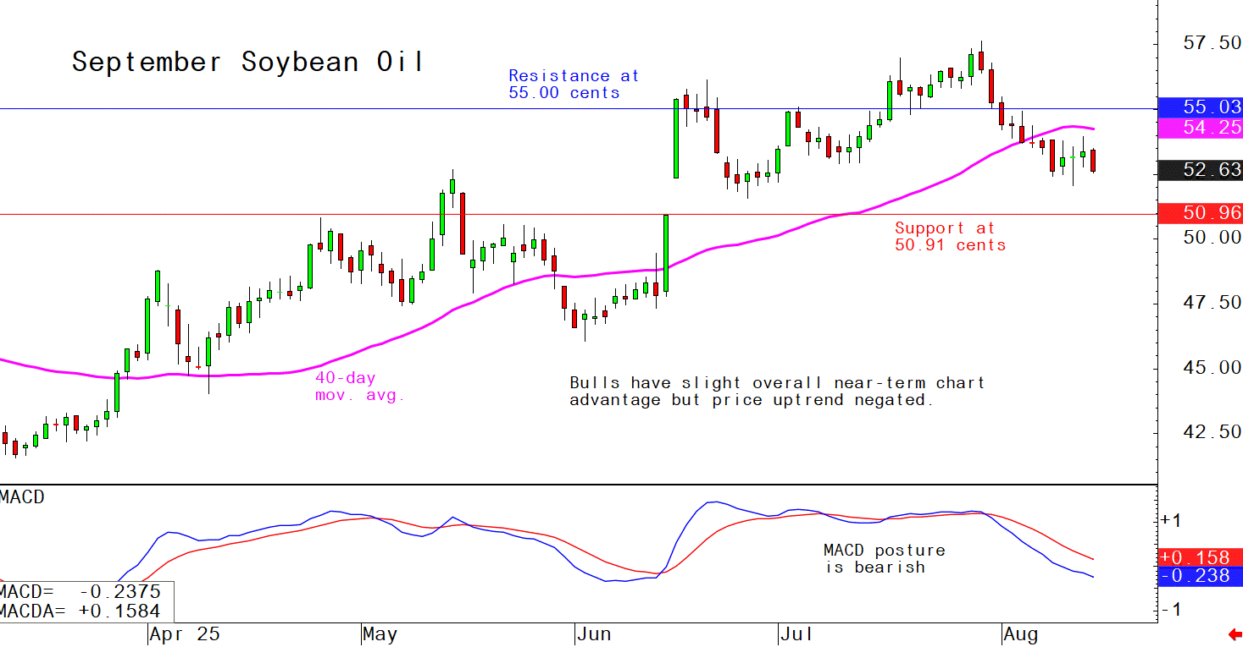

Agricultural Prices

